Year 1
Today we are learning about one more and one less.
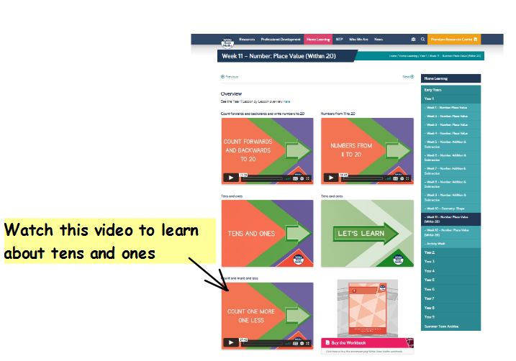
If you can, watch this video about tens and ones:-https://whiterosemaths.com/homelearning/year-1/week-11-number-place-value-within-20/

Activity:
Can you fill in the missing information to work out one more or one less?
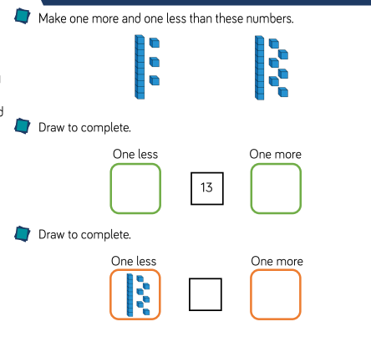

Challenge
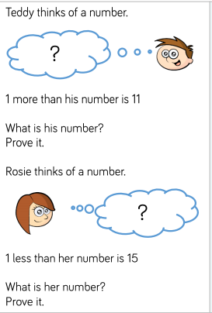

Year 2
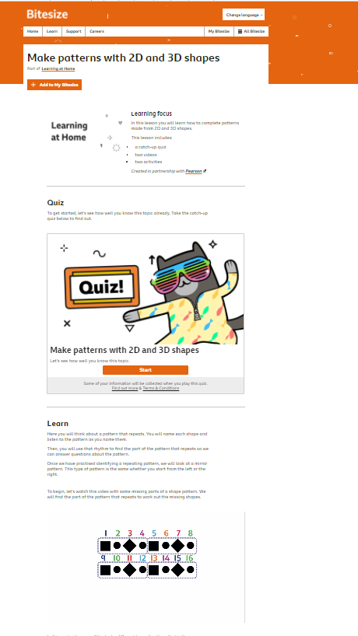
Today we are going to make patterns using 2-D shapes.
If you can, work through the BBC Bitesize page to learn about making patterns with 2-D and 3-D shapes. There is a quiz, videos and some interactive activities. https://www.bbc.co.uk/bitesize/articles/z338bqt
Activity:

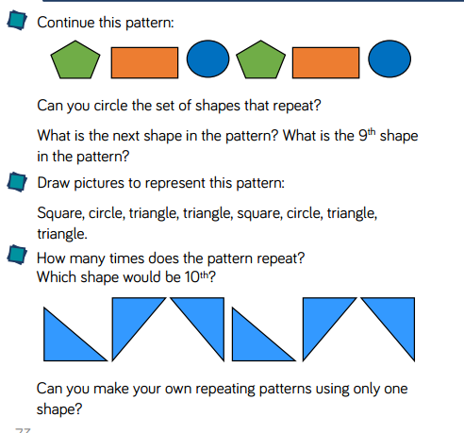

Challenge
