Year 1
Today we are learning to compare groups of objects within 20.
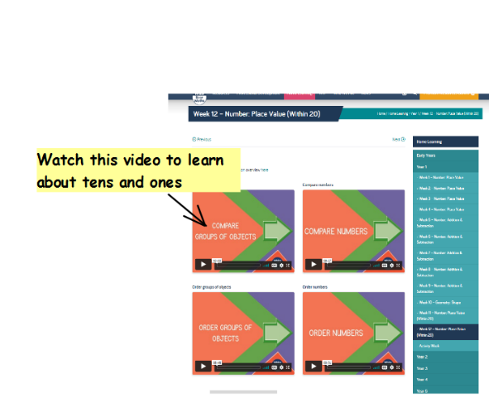
If you can, watch this video about comparing groups of objects:- https://whiterosemaths.com/homelearning/year-1/week-12-number-place-value-within-20/

Activity:
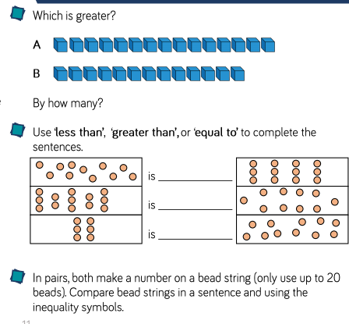
Can you compare groups of objects and answer the questions below?

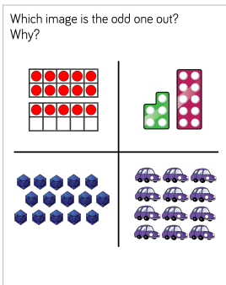
Challenge

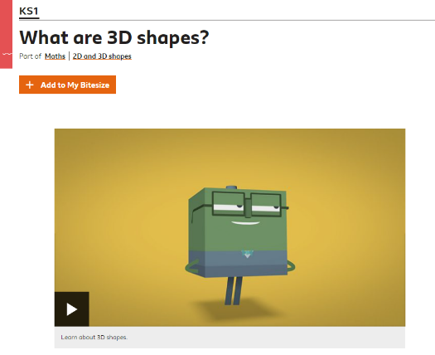
Year 2
Today we are going learn about 3-D shapes.
If you can, work through the BBC Bitesize page to learn about 3-D shapes. There is a quiz, videos and some interactive activities.
https://www.bbc.co.uk/bitesize/topics/zjv39j6/articles/zcsjqty
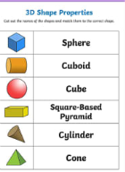
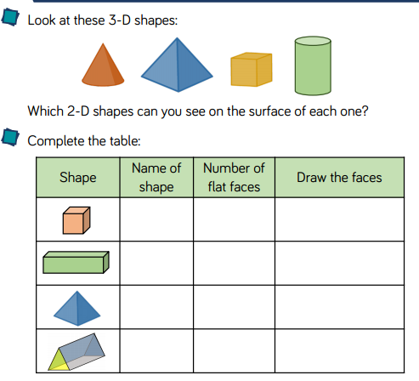
Activity:

Challenge
