Help! The Grinch is going to steal all the presents this Christmas. Can you crack the code below to find the location of the presents that he has hidden so that we can get them back?
Help Needed!
1. Answer these questions:
1. 5 + 4 =  2. 14 + 6 =  3. 6 + 3 =  4. 10 + 9 =  5. 22 + 1 =  6. 10 – 2 =  7. 2 + 3 =  8. 9 + 9 = | 9. 7 – 2 =  10. 18 + 2 =  11. 6 + 2 =  12. 10 – 5 =  13. 3 + 0 =  14. 16 – 1 =  15. 7 + 7 =  16. 6 + 5 = | 17. 7 – 2 =  18. 19 - 1 =  19. 17 + 2 =  20. 8 – 2 =  21. 3 – 2 =  22. 6 + 6 =  23. 8 + 4 =

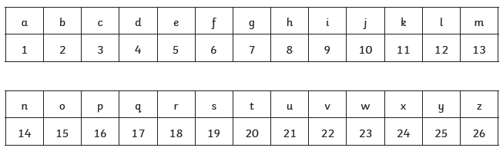
2. Work out what letter each answer is:

3. Put the letters onto these lines:
Because you are at home, please come and show me this work and you will gain your prize!
__ __ __ __ __ __ __ __ __ __ __ __
__ __ __ __ __ __ __ __ __ __ __.

