Home Learning
Maths
Today we are going to use dice to play a game. Please roll two dice. Every time you get two numbers, add them together. If they make a number that is on one of the presents below, you can colour it in.
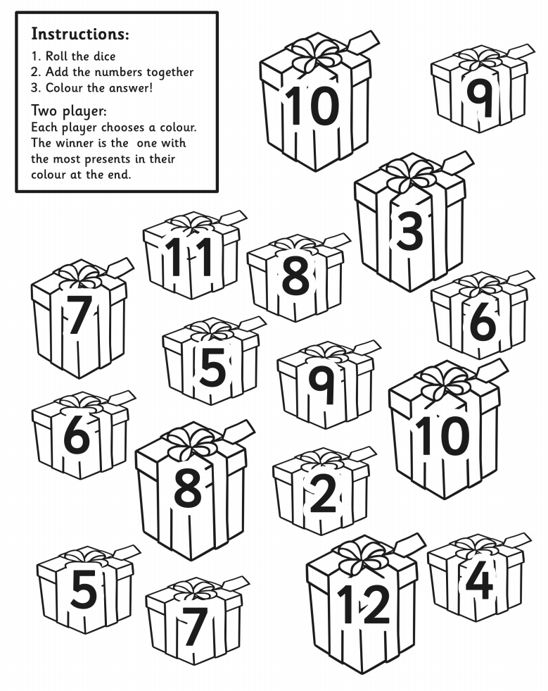
See if you can have a race with your adult!
Extension:

