7.12 Maths – Multiplication and division
Pick the section that is suitable for you. Remember, you don’t have to do them all!
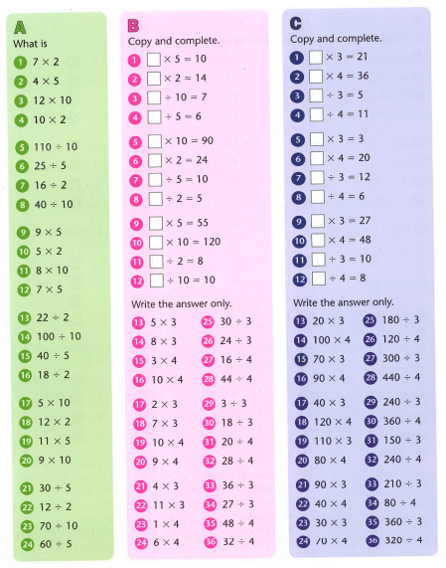

Find the answers below

