English 07.01.21

Look at the Winter Wonderland picture below.
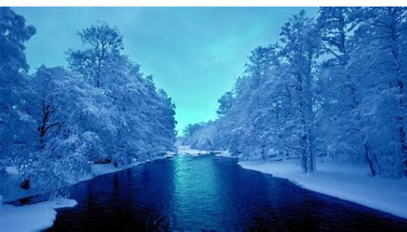
Make a list of interesting words to describe it. You can use some words from the Winter Wonderland Poem from yesterday’s session and I have listed some for you already.

- Glowing | - Crunchy
- Illuminous
- Freezing

Task
Write a detailed description of this picture using lots of interesting adjectives and verbs. You can do this in a poem (like yesterday) or you can write a detailed paragraph.

Challenge
Would you enjoy going there? Give reasons for your answer.

