English
If you are sending through email, please send to lhumphries@charing.kent.sch.uk
For this session you will need to make something! This could be anything from drawing a picture to baking a cake. I have listed some ideas for you but if you have one of your own- great!
- Draw a picture
- Junk modelling – (boxes, bottles, lids) what can you create?
- Help to prepare/ make dinner
- Construct using Lego
- If you go out for your daily exercise, you could collect natural objects from the environment and create a picture
- A painting
- Create a dance

Once you have made something, I would like you to write about it.
Try to use a variety of action verbs and not repeat them. You can use a thesaurus to help you with this (see resources). You will also need to vary your sentence starters using fronted adverbials. You can choose some from the list (see resources) but you may need to change them to make your sentence make sense. It would be great to see you vary your punctuation too. If you are listing- you need to use commas to separate each item in your list (see my example highlighted in yellow). How far can you climb the punctuation ladder (see resources)?

Example text
Today, I created a boat using cardboard, toilet rolls, Lego and sticky tape.
First, I…
Slowly, I…
After that, my boat needed some colour so I painted it with a bright, shimmering, red paint. It looked fantastic because…
Lastly, the boat needed a captain; for this I used…
I like what I have made because…
If I could make it again, I would change…

If you can, take a photo of what you have made and send it along with your writing.
Resources
https://www.thesaurus.com/
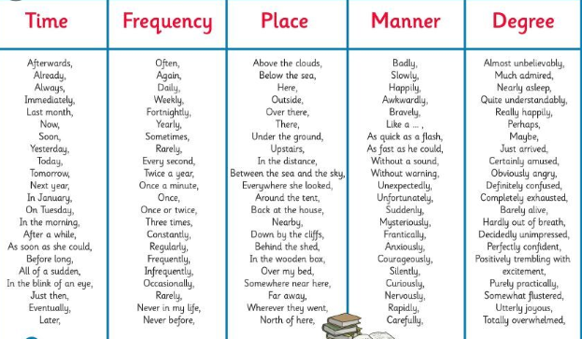
Fronted Adverbials
