If you need to send your completed work via email, please send to lhumphries@charing.kent.sch.uk

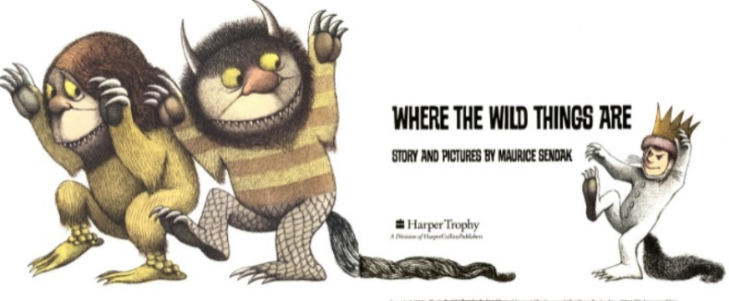
English
For English, we are going to read the story Where the Wild Things Are by Maurice Sendak.

Read the story Where the Wild Things Are- https://www.slideshare.net/samsmith_12345/maurice-sendakwherethewildthingsare
https://www.youtube.com/watch?v=ALmNPxNehYE
Once you have the read the story, I would like you to think about the following questions. You may want to share your answers with someone.

- On ‘That night in Max’s room a forest grew’
Did the forest grow? Did this really happen? Fantasy of reality, yes or no?
- On the page where ‘Max gave up being king of where the wild things are’
Would you like to stay or would you like to go back to your normal life? Why?
- Did this really happen to Max? Why/ why not?

Think about the events in the story and the different emotions that Max feels.

Writing Task
Write descriptive sentences underneath each picture taken from the story to describe how Max was feeling and why.
You can magpie words from the list of emotions (see resources).
If you are completing your work on paper, you can draw the pictures and write your sentences underneath.

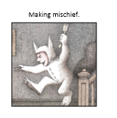 | 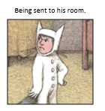
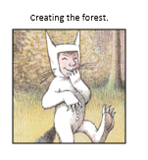 | 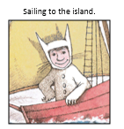
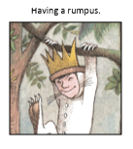 | 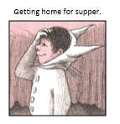

Resources

https://www.slideshare.net/samsmith_12345/maurice-sendakwherethewildthingsare
https://www.youtube.com/watch?v=ALmNPxNehYE

List of emotions
