If you need to send your completed work via email, please send to lhumphries@charing.kent.sch.uk
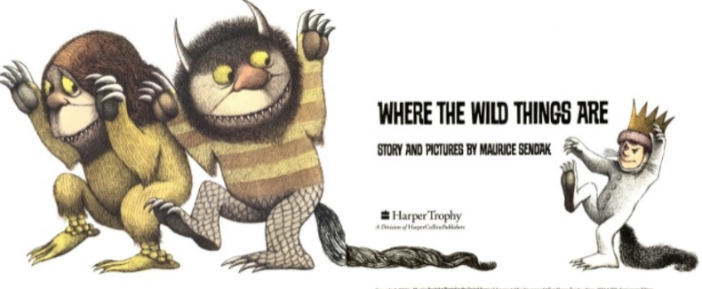
English
For English, we are going to read the story Where the Wild Things Are by Maurice Sendak.
Read the story Where the Wild Things Are- https://www.slideshare.net/samsmith_12345/maurice-sendakwherethewildthingsare
https://www.youtube.com/watch?v=ALmNPxNehYE
Writing Task
Using the work that you completed yesterday, I would like you to write a diary entry in the role of Max. Imagine that you are Max and you have just returned home from your adventure. You will need to write about each event in the story to describe what happened to Max and you can use the picture and captions from yesterday to help you with this. In addition, you will need to describe how Max was feeling throughout his adventure and again use the work that you did yesterday to describe his emotions.
For each event you should start a new paragraph- (a new line)
You should climb as high as you can on the punctuation ladder.
You need to use the features of a diary checklist to complete your diary.

This piece of writing will extend over two sessions- today and tomorrow.

Features of a diary checklist
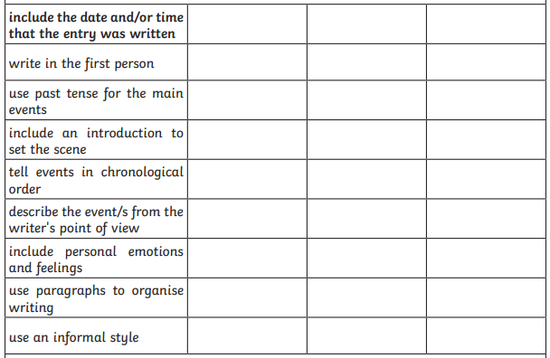

Challenge
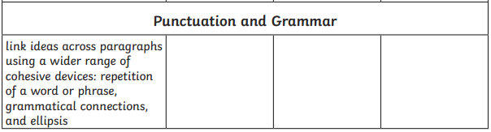

Resources

Example text

Wednesday 20th January 2021

Dear Diary

Today, I have been on a truly remarkable adventure! You would not believe where I went and who I met. I have had the most incredible experience and I am going to tell you all about it…

Earlier this afternoon, I was feeling very mischievous. I don’t know what came over me but I suddenly felt so energetic and so I started to chase the animals around the house.

My mum was extremely unhappy with me and so she sent me to my room. Furiously, I stomped up the stairs and into my bedroom. I sat on my bed and felt so… Because…

As time passed, I started to feel energetic again and I needed to do something. I felt overjoyed and creative so I decided to create a forest in my room. It had… I felt delighted because…

Soon after, I was Sailing to an island…

Later, I arrived at the island! It was incredible…

Finally, I arrived back home…

Until next time,
Max

Order of events from beginning to end (chronological order)
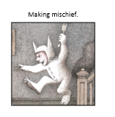 | 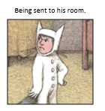
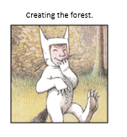 | 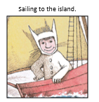
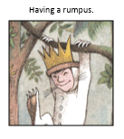

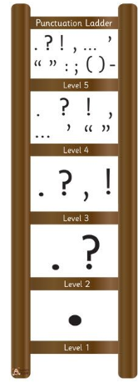

List of emotions
