If you need to send your completed work via email, please send to lhumphries@charing.kent.sch.uk

Watch this short video on prepositions. You will be using these in your work this week.
https://www.bbc.co.uk/bitesize/topics/zwwp8mn/articles/zw38srd

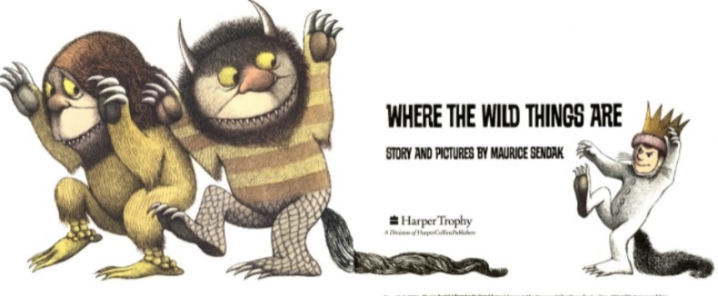
English
For English, we are reading the story Where the Wild Things Are by Maurice Sendak.
Read the story Where the Wild Things Are- https://www.slideshare.net/samsmith_12345/maurice-sendakwherethewildthingsare
https://www.youtube.com/watch?v=ALmNPxNehYE
Writing Task

This week, we are going to focus on the part of the story where Max had fun with the ‘Wild Things’.
You are going to describe the fun experiences that Max and the Wild Things encountered.
You will need to use lots of prepositions to describe where and when they had fun.

Write at least two sentences next to each picture to describe their fun experiences. You can use the prepositions in the table below.

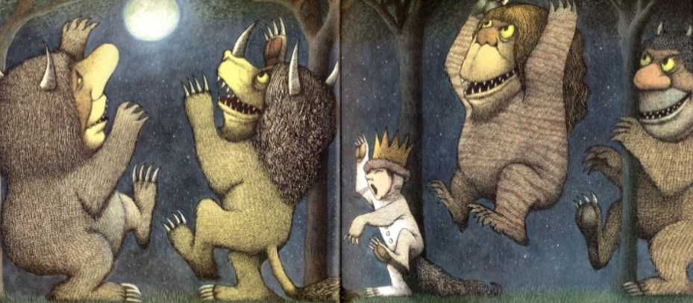

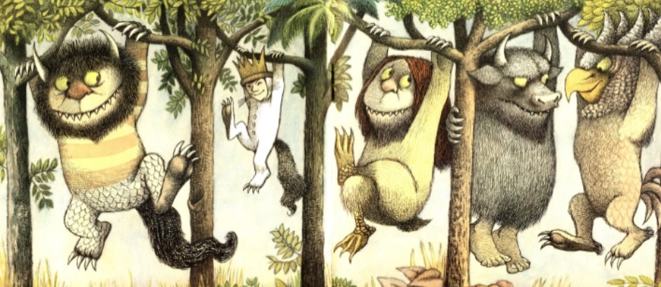

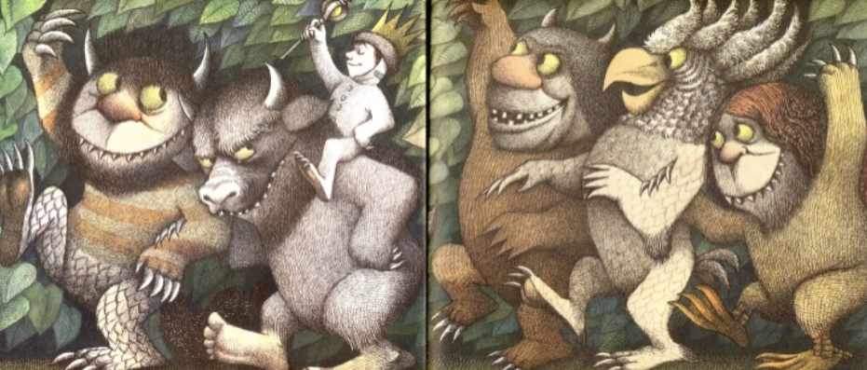

List of prepositions
during | over | at
in | above | with
up | after | into
under | around | inside
on | off | through
behind | outside | near

Resources

https://www.slideshare.net/samsmith_12345/maurice-sendakwherethewildthingsare
https://www.youtube.com/watch?v=ALmNPxNehYE
Where the Wild Things Are Word Bank
