If you need to send your completed work via email, please send to lhumphries@charing.kent.sch.uk

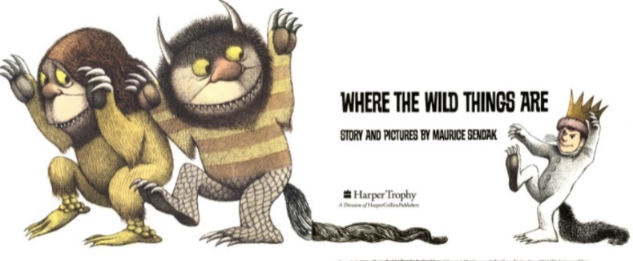
English
For English, we are reading the story Where the Wild Things Are by Maurice Sendak.
Read the story Where the Wild Things Are- https://www.slideshare.net/samsmith_12345/maurice-sendakwherethewildthingsare
https://www.youtube.com/watch?v=ALmNPxNehYE

Writing Task

This week, we are going to focus on the part of the story where Max had fun with the ‘Wild Things’.
You are going to describe the fun experiences that Max and the Wild Things encountered.

You are going to write an informal letter in the role of Max. You will need to decide who you are going to write to, it could be a relative or a friend. The letter will be all about the fun that you have encountered with the ‘Wild Things’.
Your first paragraph will describe why you are writing to them.
After that, you can write a paragraph to describe each picture that shows the fun that you have encountered. You can use your work from yesterday to describe each picture but you will need to add some more detail and make sure that your sentences flow by using interesting sentence starters.

This piece of work will continue over Thursday and Friday.

Look in the resources section for an example of how to set out an informal letter, the pictures of each fun encounter and a word bank to help with your spelling.

Resources

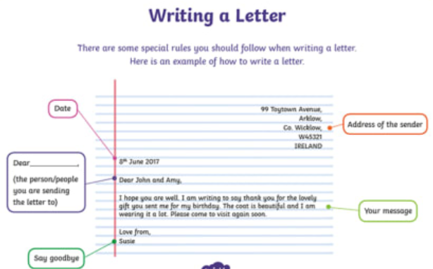

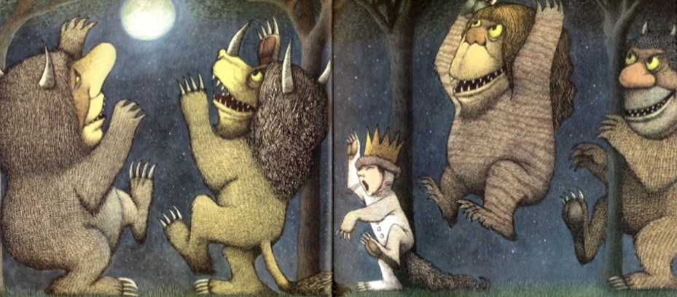

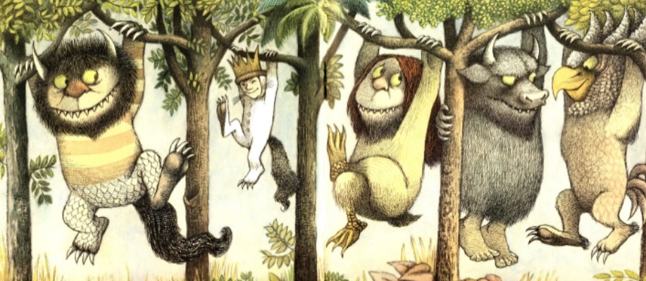

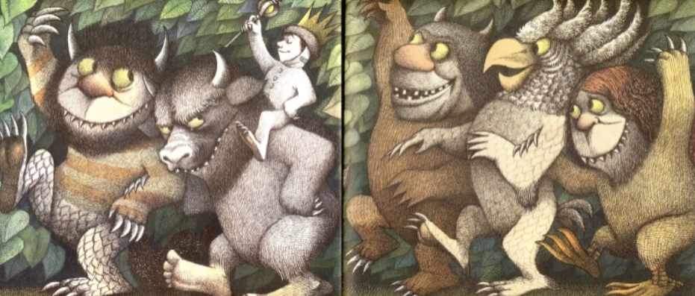

https://www.slideshare.net/samsmith_12345/maurice-sendakwherethewildthingsare
https://www.youtube.com/watch?v=ALmNPxNehYE
Where the Wild Things Are Word Bank
