English Home Learning
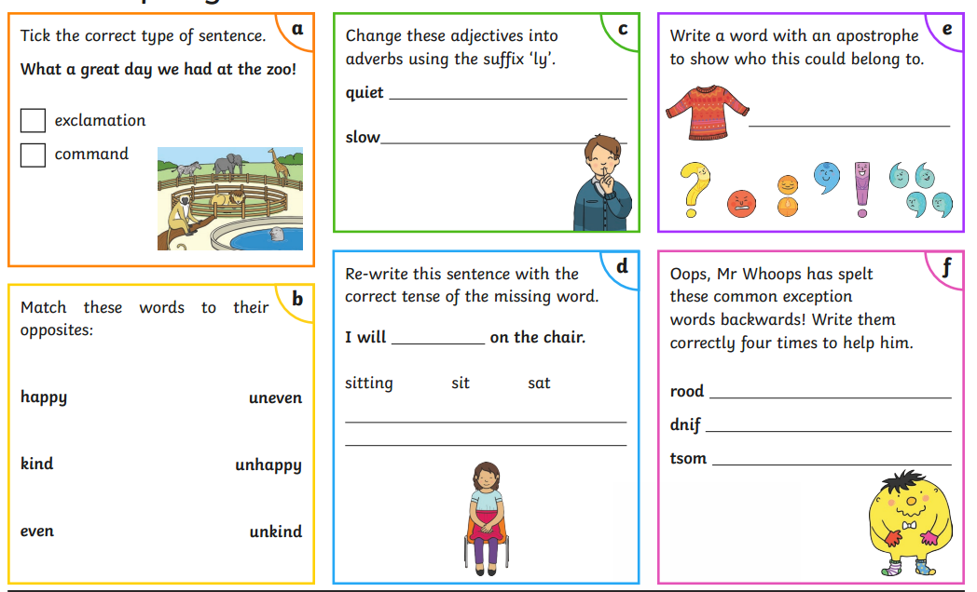

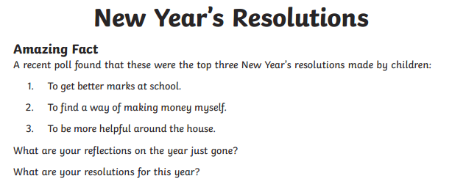

Task
Write a detailed paragraph reflecting on the year just gone, describing your highlights and challenges you may have faced. Continue to write about any resolutions that you have for this year.
Ideas for writing
- A fun day/ night at home
- Your Summer out of lockdown- what did you do? Where did you go?
- Starting Year 3 in September
- Christmas
- Your birthday
Try and vary your sentence starters to make your writing more interesting.

