15.01.21

Some more practise for long multiplication. Answers are below so no peeping. Remember to write the calculations out neatly. Do as many of the problems as you need to complete to feel confident then try at least 1 challenge question.
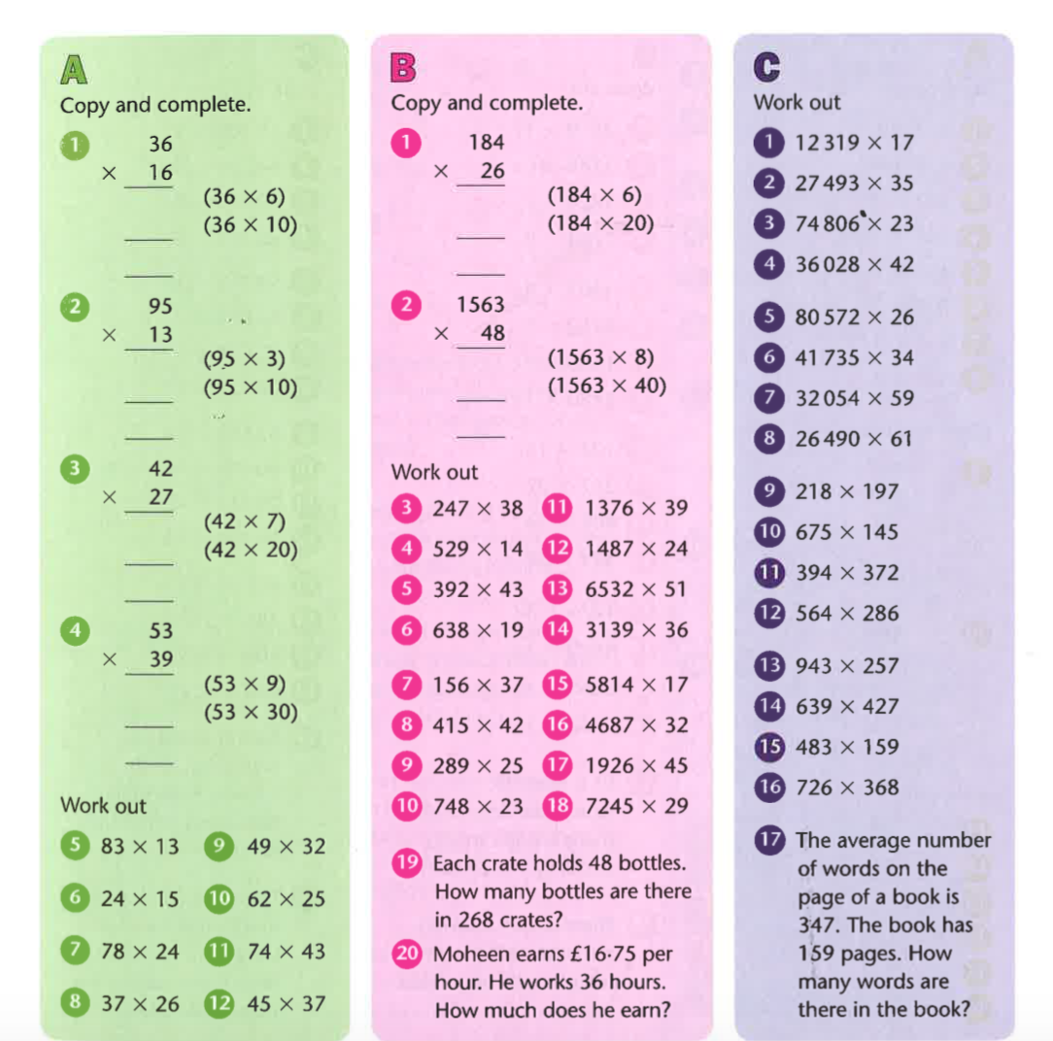

Challenge Questions.

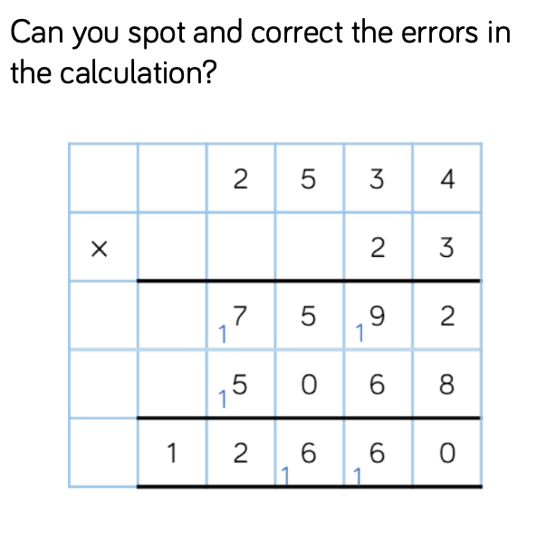

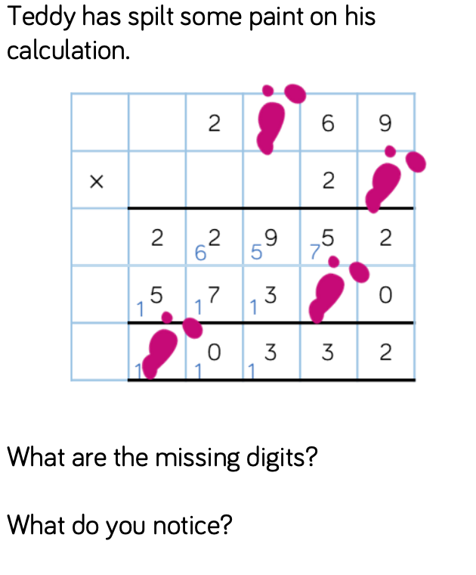

Answers
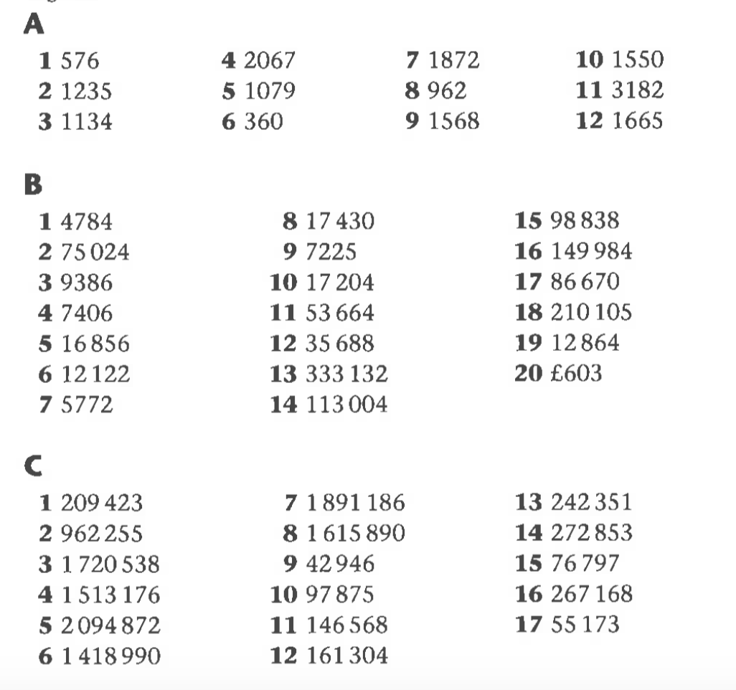

Challenge

1. There are 2 errors. The first is in the first line of the working, the exchanged ten has not been added. In the second line of working, the place holder (0) is missing. The correct answer is 58,282

2. All the missing digits are 8.

