22.01.21
Maths

Start by completing your timestable square.

Then complete the following. Choose the section you are the most comfortable with. All the questions below will have remainders. You need to decide if it is appropriate to round the answer up or down. For example if egg boxes can hold 6 eggs and you have 38 eggs. How many boxes would you need. The answer is 7, even though the 7th box will not be filled, so you would round the answer or 6 r2 up to 7 because you need 7 boxes to hold all the eggs.

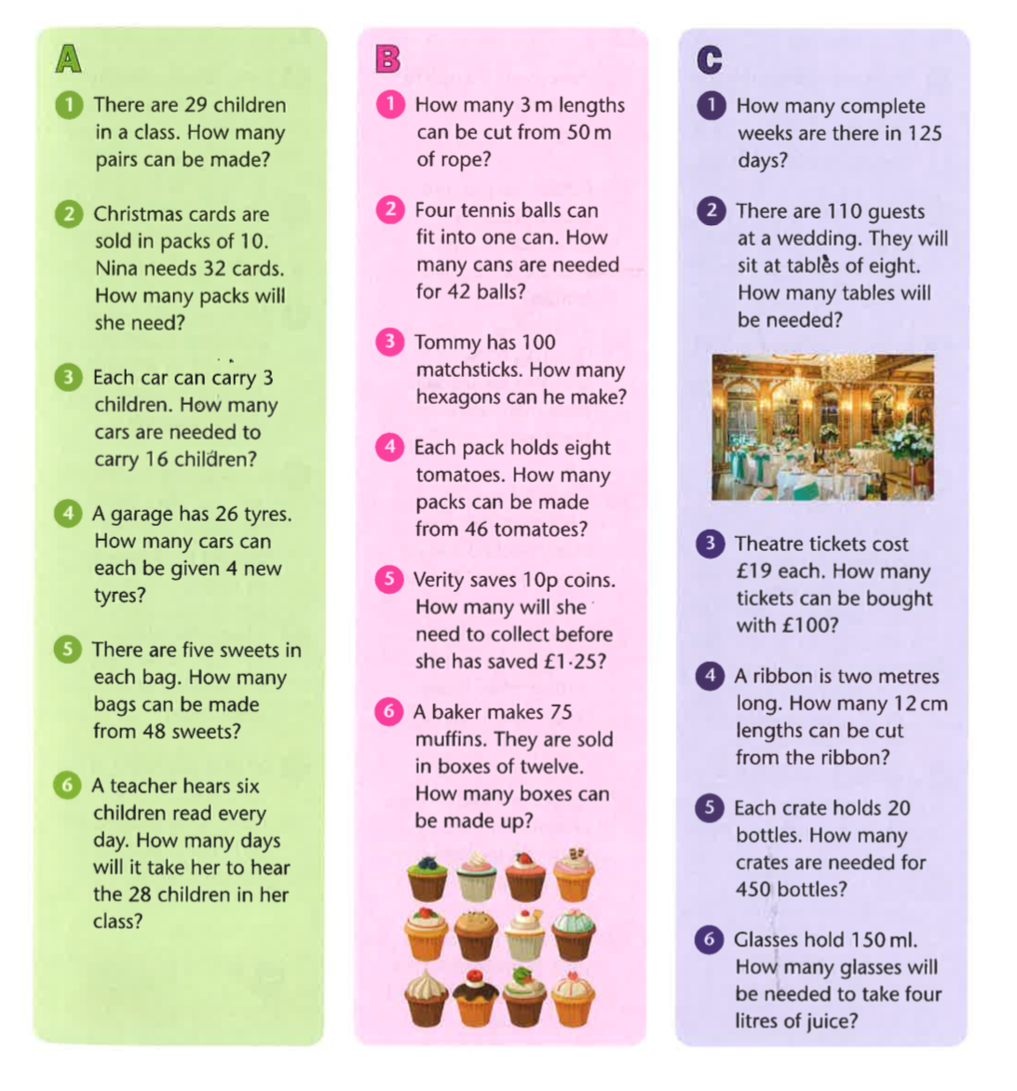

EXTENTION

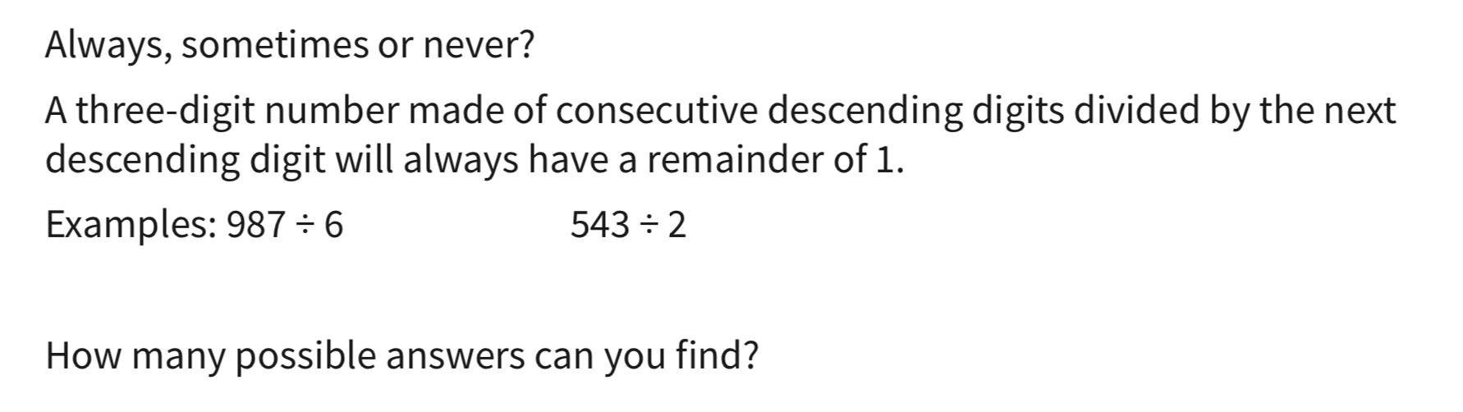

2 – Write a word problem where you round the remainder up.
3 – Write a word problem where you round the remainder down.
4 – Write a word problem where you have to find the remainder.

ANSWERS

