Friday 15th January 2021

Add the correct punctuation to the sentences below.

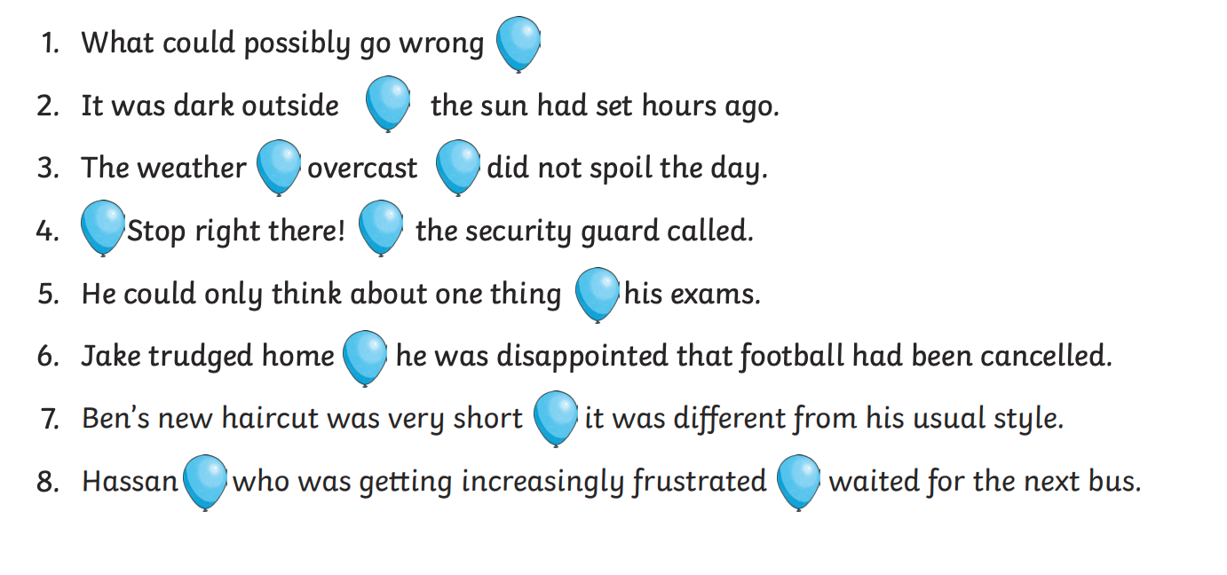

If you need a clue, these balloons will help you.

