Grammar 11.1.21
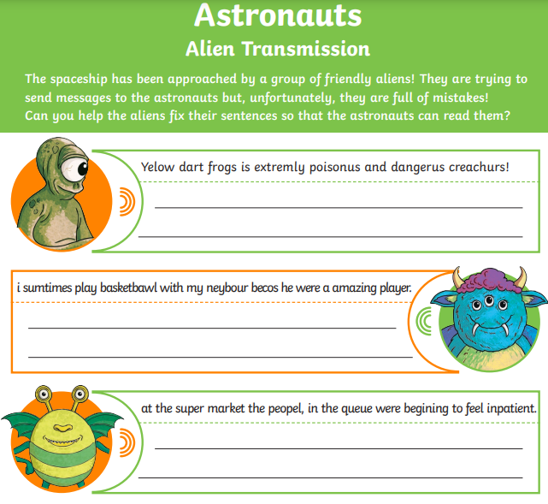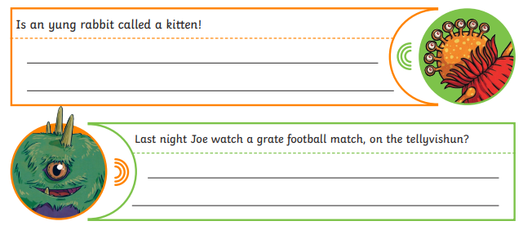
If you finish making the corrections, please learn as many of these words as you can.

