Multiplication and division 11.1.21

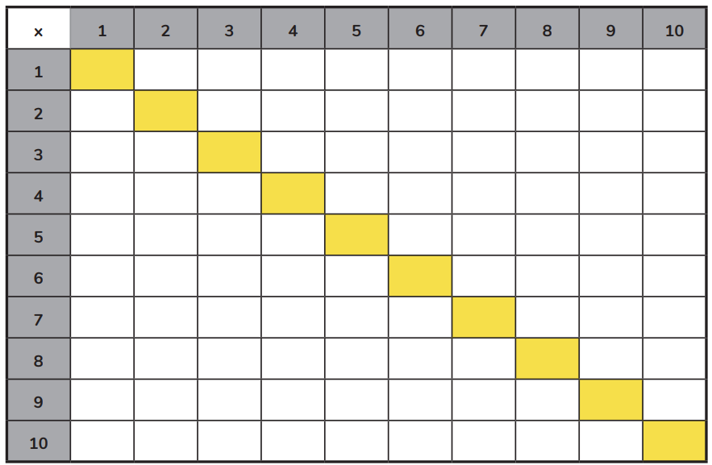

Fill in as much of this multiplication grid as you can. Remember to start with the easy ones first eg 2,5,10.

Now have a go at filling in as many of the questions below as you can. Don’t worry if you can’t do it all. Hint, remember that division is the inverse of multiplication.

