Maths- Multiplication using the column method.
If you are emailing your completed work, please send to lhumphries@charing.kent.sch.uk
Choose the pink or blue set of questions to complete. Complete each multiplication problem using the column method.
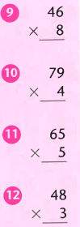
Use scrap paper for your working out and write your answers in the spaces below.
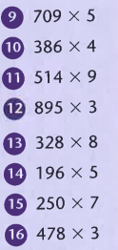
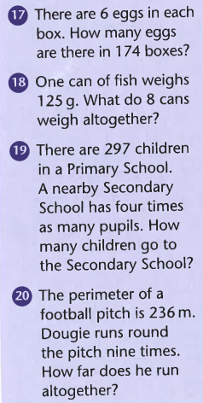
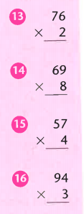

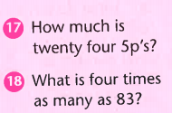

Answers
9
10
11.
12.
13.
14.
15.
16.
17.
18.
19.
20.

Challenge

