Maths 18.1

Go to the following page to remind yourself how to multiply using partitioning.

[Partitioning numbers to multiply (2-digits X 1-digit) - Bing video](https://www.bing.com/videos/search?q=multiplying+a+2+digit+number+by+1+digit+partitioning&docid=608021680141044507&mid=D4DC666A6AA6EE17120BD4DC666A6AA6EE17120B&view=detail&FORM=VIRE)

You will need some paper and a pencil to work out the following.

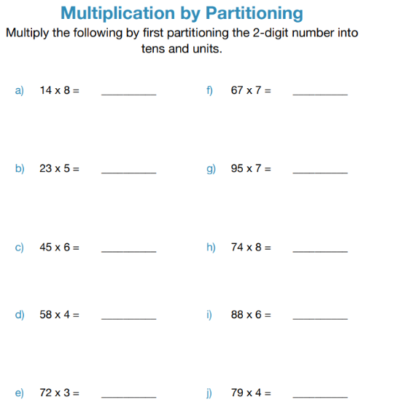

Use the multiplication grid below, if you get stuck.

