19.01.21

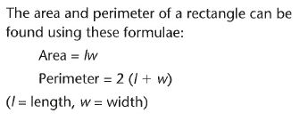
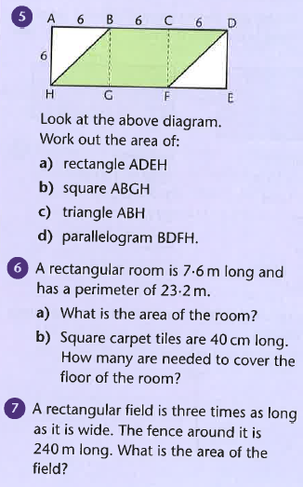
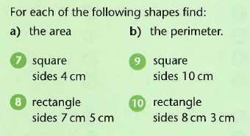
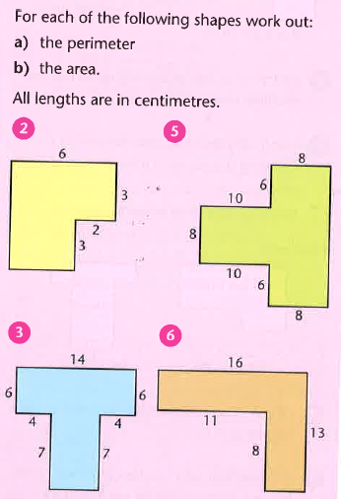

Challenge
- Two shapes both have areas of 36cm², but different perimeters (24cm and 30cm). Using whole-number measurements, how many other rectangles or squares can you find that have an area of 36cm² but different perimeters?
- Using whole-number measurements, find as many squares and rectangles you can which have an area of 24cm², but have different perimeters.

