Maths 19.1
Have a go at answering as many of these as you can. You don’t have to do all of them… Unless you really want to!
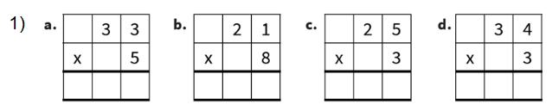

2)
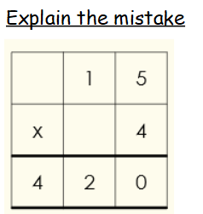

3)
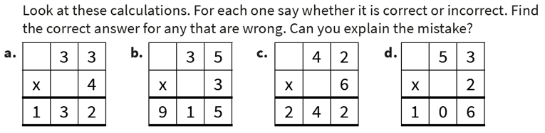

4) How close to a hundred can you make these answers?
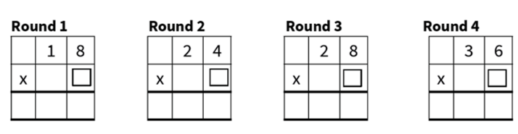

Use partitioning to help you with these!
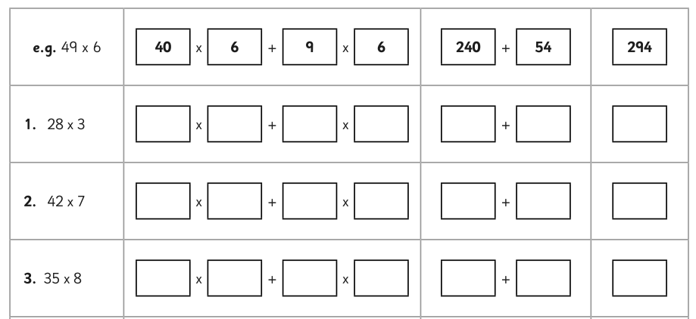

Challenge
Create some word problems of your own.

