Maths 20.1.21

Multiplying two digits by 1 digit.

You don’t have to do all of these. If you need to contact me, my email address is: [**AZaffar-Thompson@charing.kent.sch.uk**](mailto:AZaffar-Thompson@charing.kent.sch.uk)

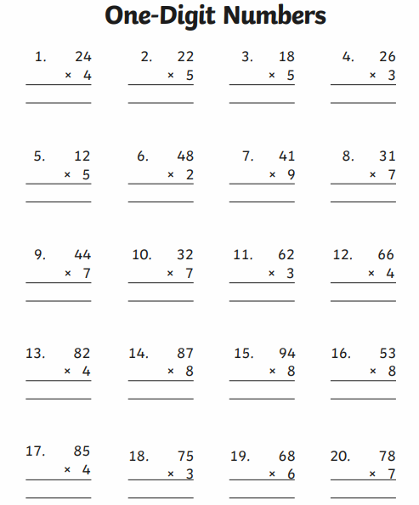

Find the answers below.

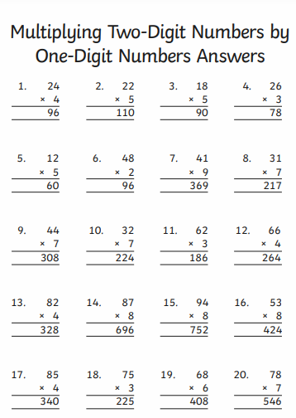

Now try the challenge

