Maths 25.1.21 division

**Use the part whole (partitioning) method to complete the following calculations.**

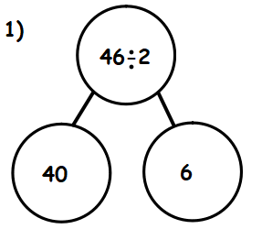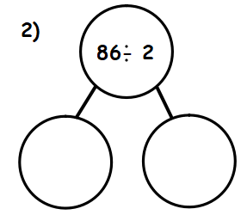

**Continue to use the part whole model to complete the following.**

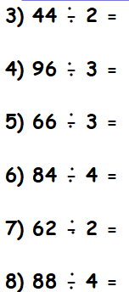

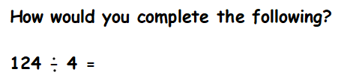

**Challenge**

