**Maths 26.01.21**

**A**

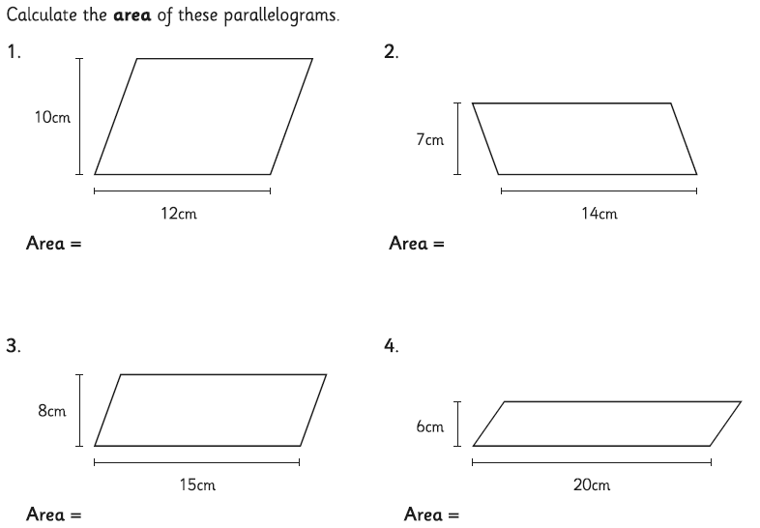

**B**

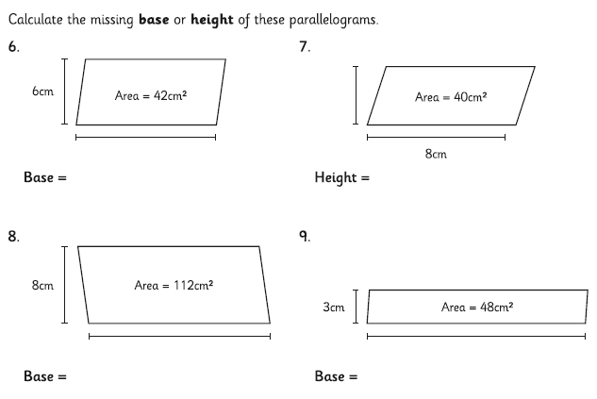

|  |
| --- |
| **C** |
| **Challenge** |