**Maths 27.01.21**

**A**

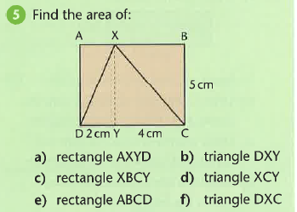

**B**

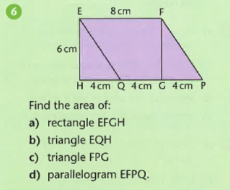

**C**

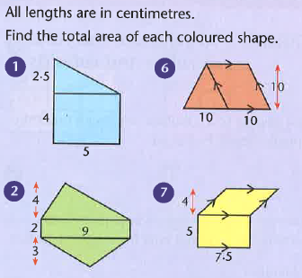

|  |  |
| --- | --- |
| **Challenges** |  |