Maths - 27.1.21
Pick the ones that are suitable for you. You do not have to do them all but try to do some from each section if you can.
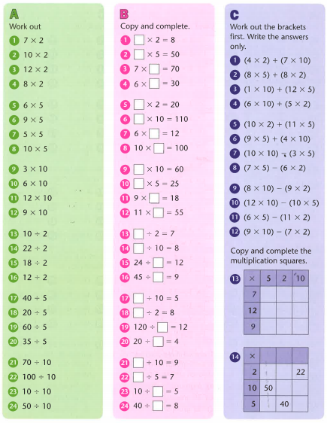

Challenge - below

