Maths – Revision 4.1.21
Choose the section that is best suited to you. Try to do a few questions from each section. You don’t need to do them all!
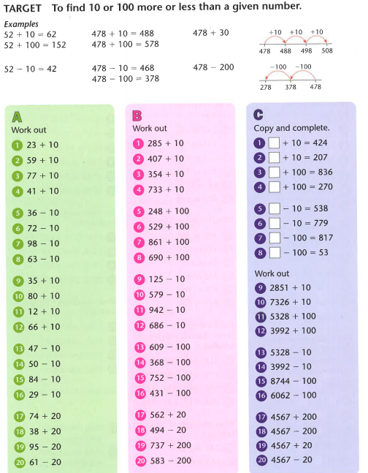

Use the 100 square below to help if you get stuck.

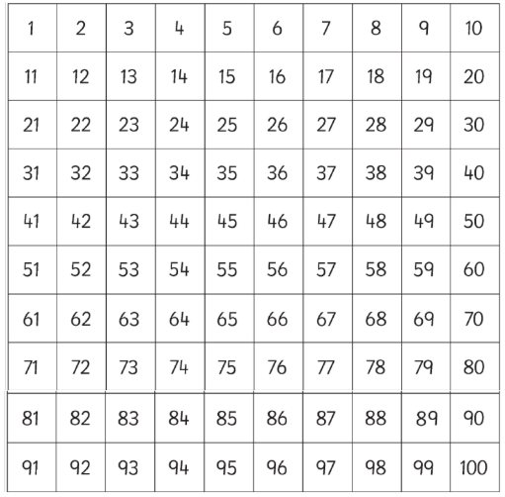

Find the answers below
