Maths 5.1.21 – Revision – addition and subtraction
Choose the sections that best suit you. Try to do some from each section. You do not need to do them all!
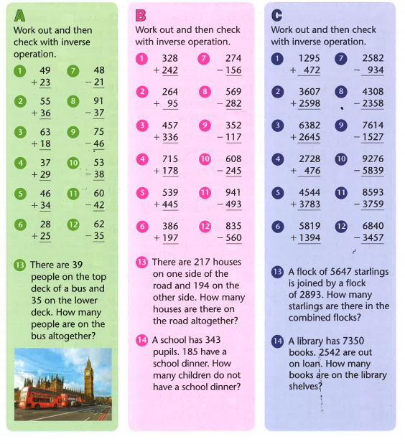
Find the answers below

