Maths Home Learning

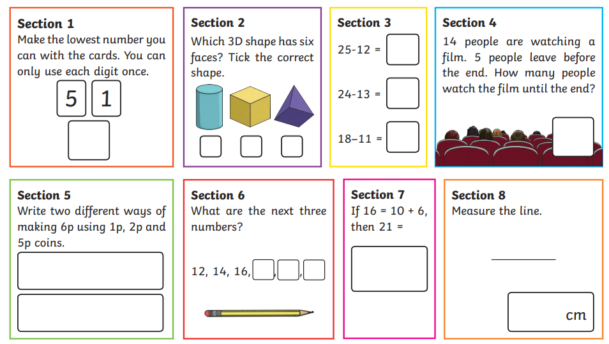Task 1

Task 2

Practise the 3 times table. You could practise with an adult at home or by yourself.

When saying them out loud, say the whole number sentence and don’t just count in steps of 3.

For example- say “1 x 3 = 3” “2 x 3 = 6” and not 3, 6, 9…

1 x 3 = 3

2 x 3 = 6

3 x 3 = 9

4 x 3 = 12

5 x 3 = 15

6 x 3 = 18

7 x 3 = 21

8 x 3 = 24

9 x 3 = 27

10 x 3 = 30

11 x 3 = 33

12 x 3 = 36