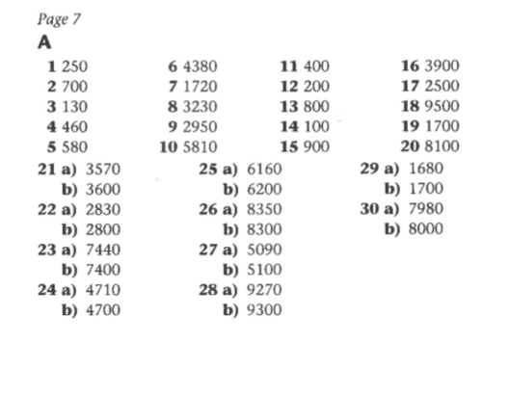
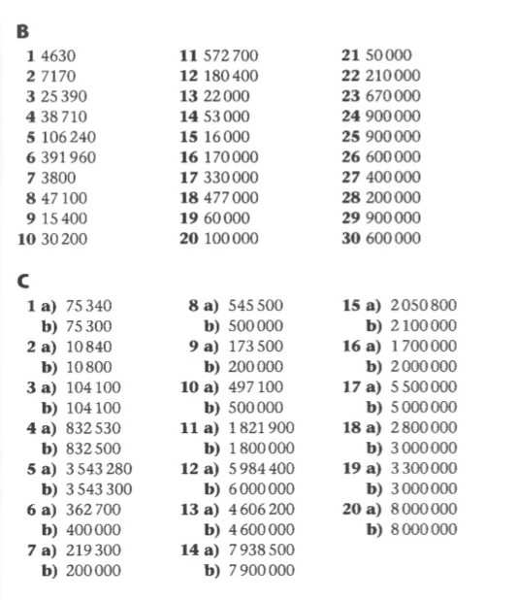

Challenges

Jack’s numbers could be 1145 to 1154
Whitney is incorrect. 2,567 rounded to the nearest 100 is 2,600.
Teddy has forgotten that all the digits to the right of the number rounded become 0.

