25.01.21

Maths – Today have a go at the questions below to keep our multiplication and division skills fresh in our minds. Answers are at the bottom so no peaking.

To warm up have a go at making as many ways to make 32 by **adding** 3 numbers together. You may only use the numbers from the box below. Use can only use them once per calculation.

|  |  |  |  |
| --- | --- | --- | --- |
| 18 | 15 | 8 | 20 |
| 32 | 5 | 3 | 14 |
| 17 | 15 | 6 | 9 |
| 7 | 16 | 19 | 21 |

How many groups can you find in 5 minutes?

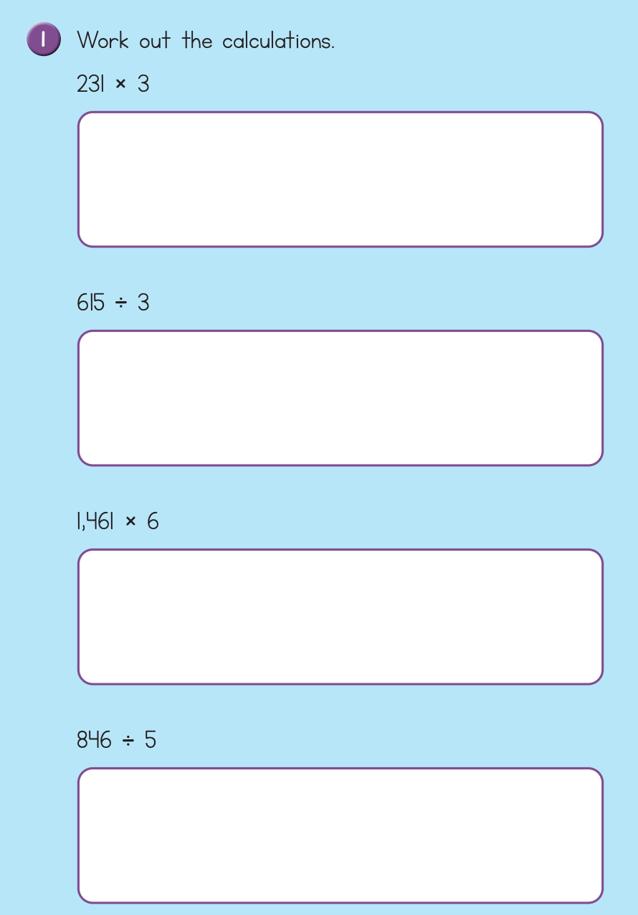

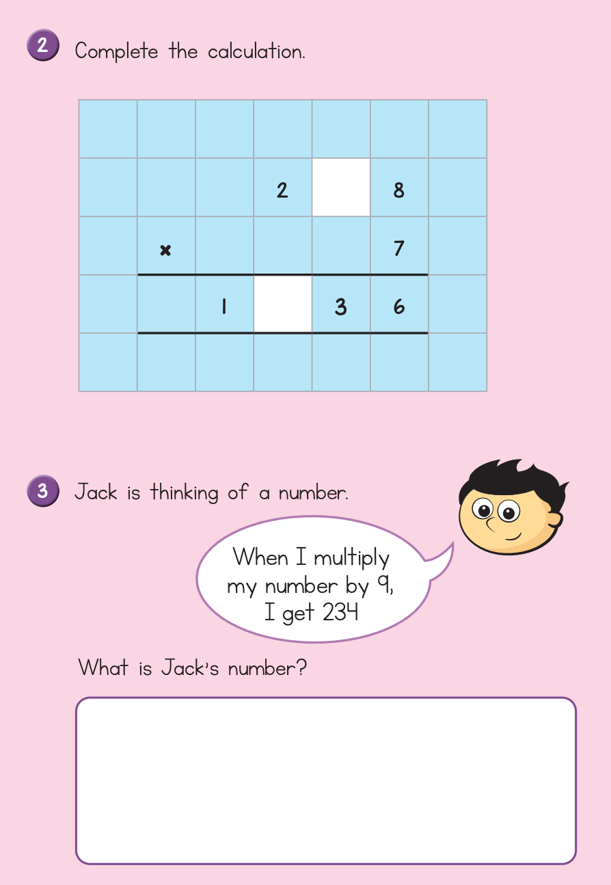

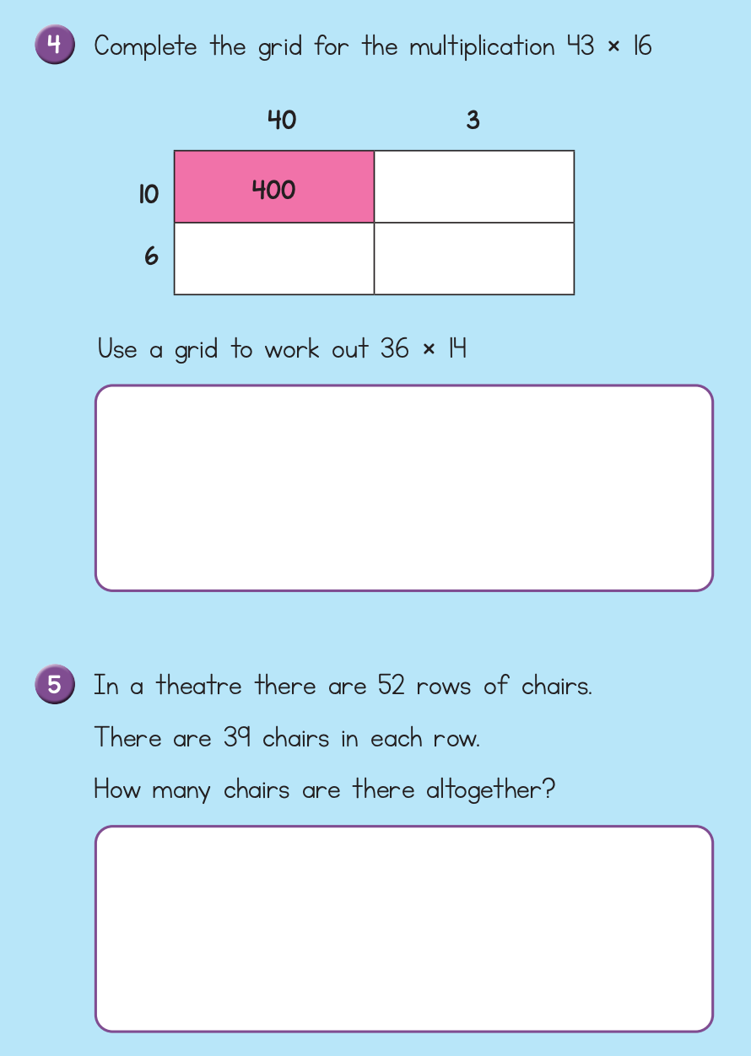

**CHALLENGE QUESTIONS**

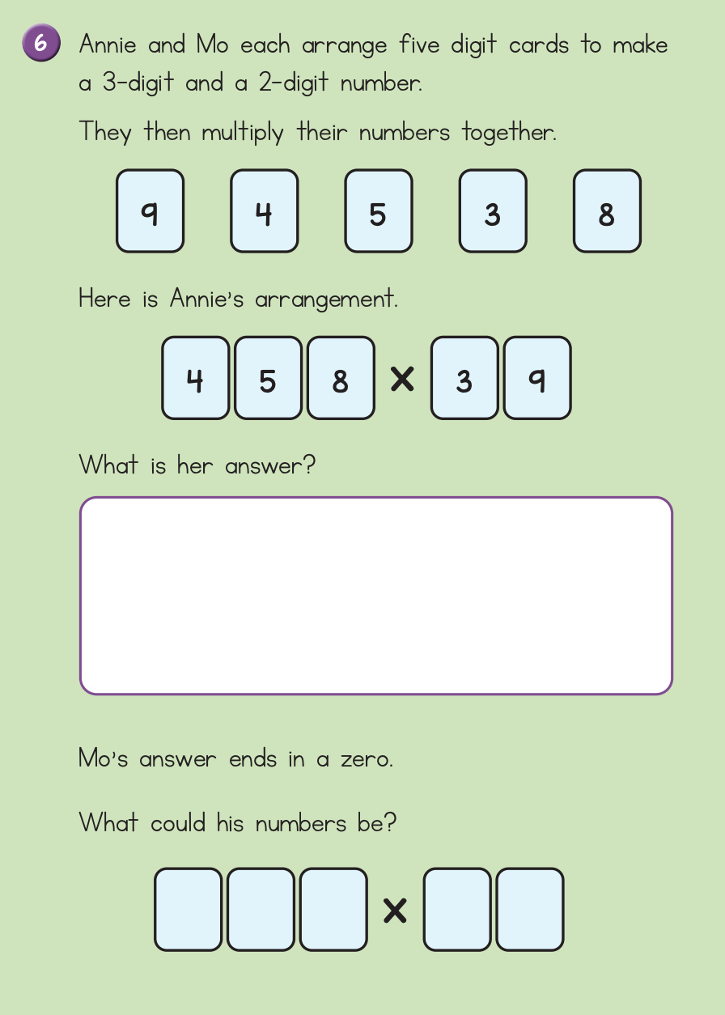

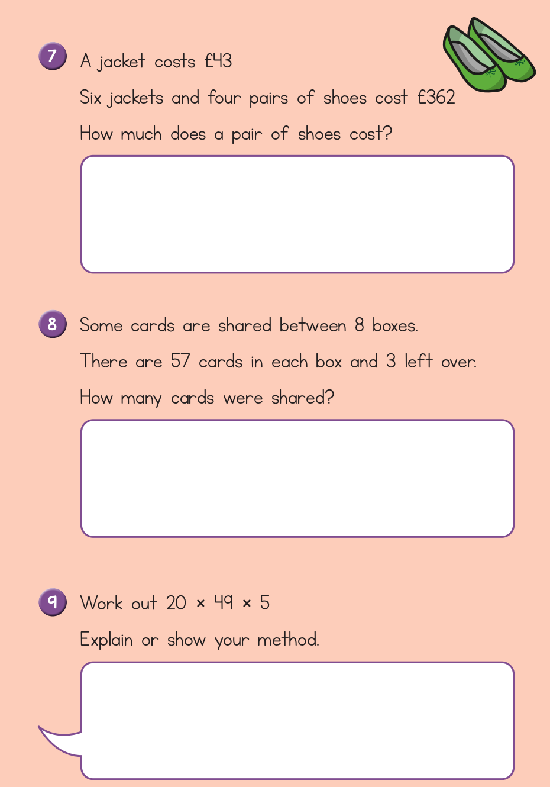

ANSWERS

