Punctuation 13.1.21

You don’t need to complete all the activities but try to complete at least two.

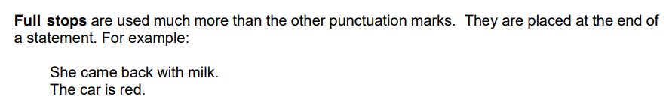

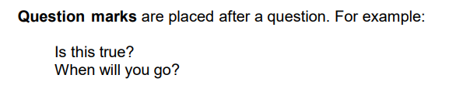

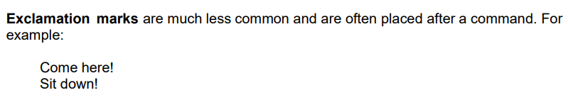

Activity 1

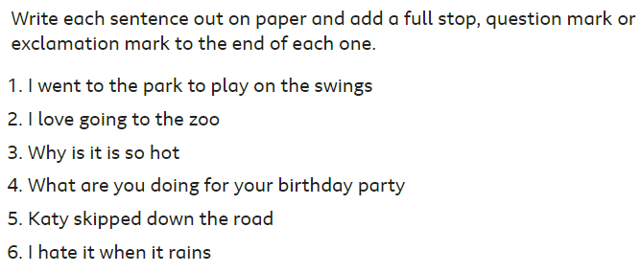

Activity 2

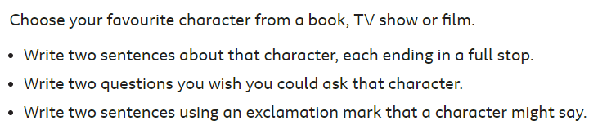

Activity 3(Challenge)

Add full stops, exclamation marks, question marks and anything else you think you might need to make the following passage make sense.

