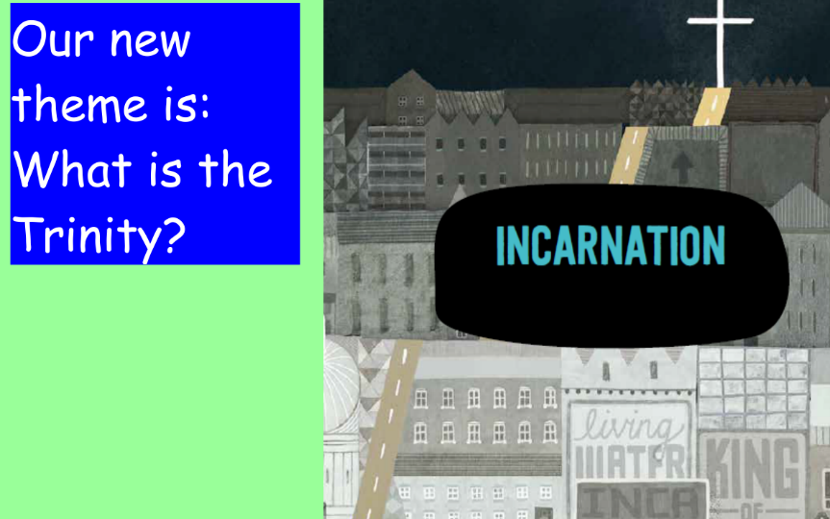
R.E.
If you need to send your completed work via email, please send to lhumphries@charing.kent.sch.uk

This week we are going to learn about the symbols that are important at the baptism of Jesus.

Watch this short animation video to learn about the importance of John the Baptist. https://www.youtube.com/watch?v=_OO84K9RuF0

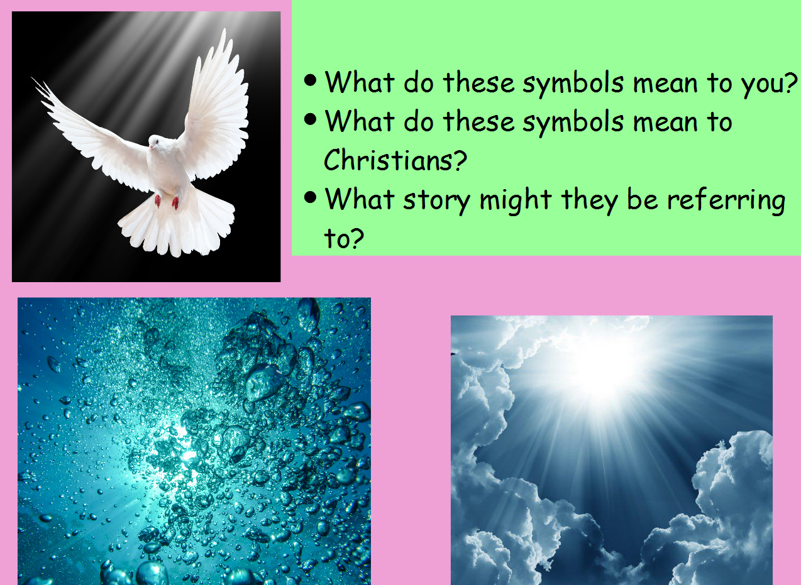

Read the story of the Baptism of Jesus and think about what the water, dove and the voice all mean in this story?
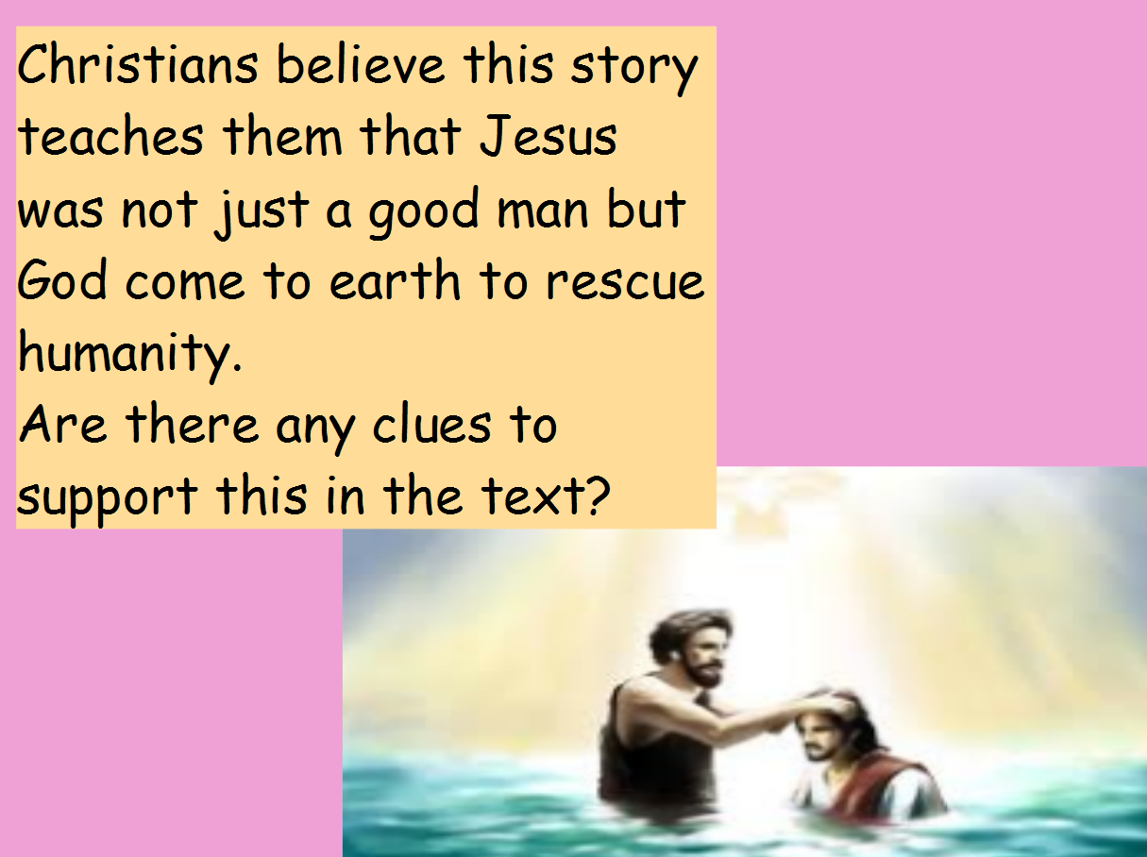
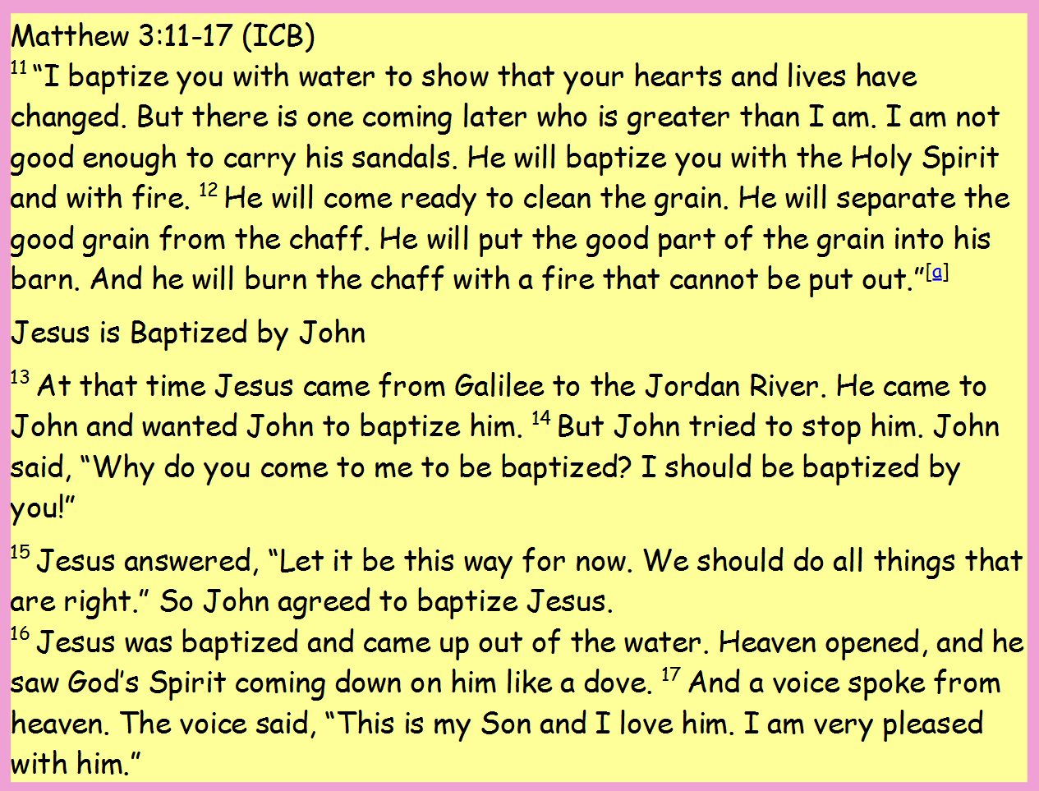

Task
Create your own image of the baptism of Jesus. Use different symbols to show the voice of God and the Holy Spirit. You can complete your work on paper and send a photo.

Challenge
Which symbol do you think is most important and why?

