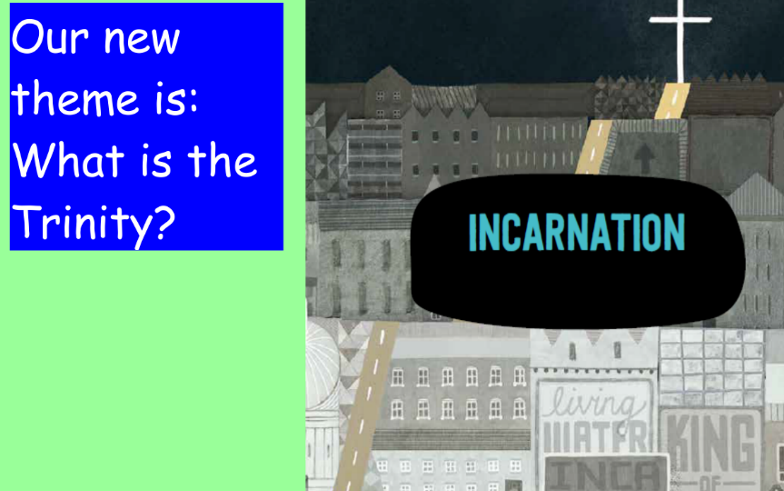
R.E.
If you need to send your completed work via email, please send to lhumphries@charing.kent.sch.uk
This week we are going to learn about how the Trinity is referred to in the Bible.
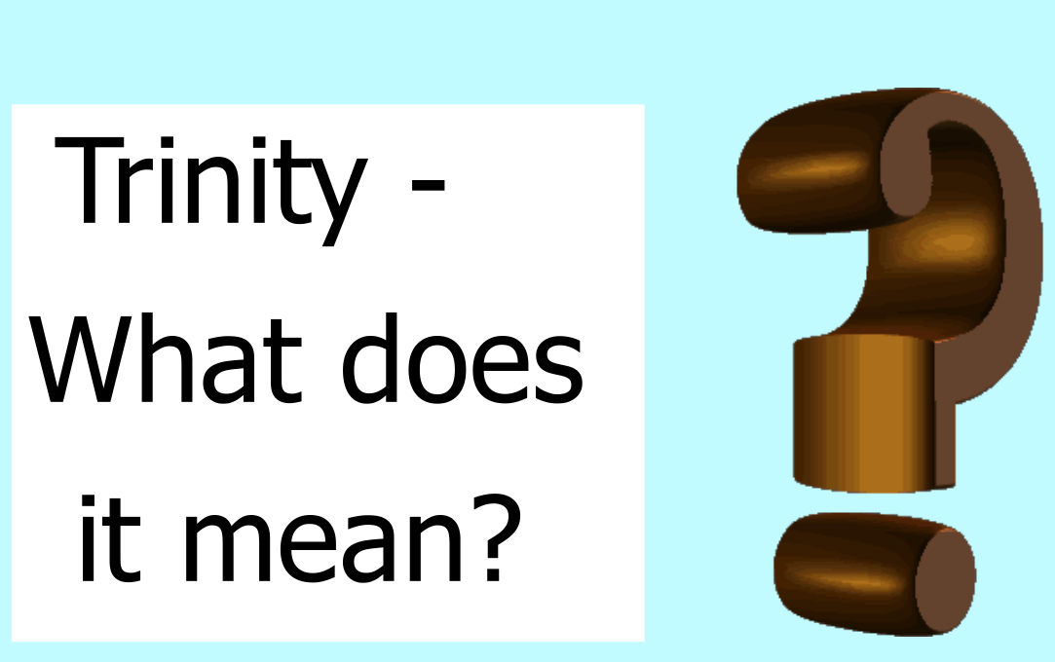

Trinity is the unity of three.
What does this mean about God? Watch this video to find out!
https://uk.video.search.yahoo.com/search/video?fr=mcafee&p=what+is+the+trinity+KS2#action=view&id=1&vid=5728b0db5672b47c3886d38f12c93546

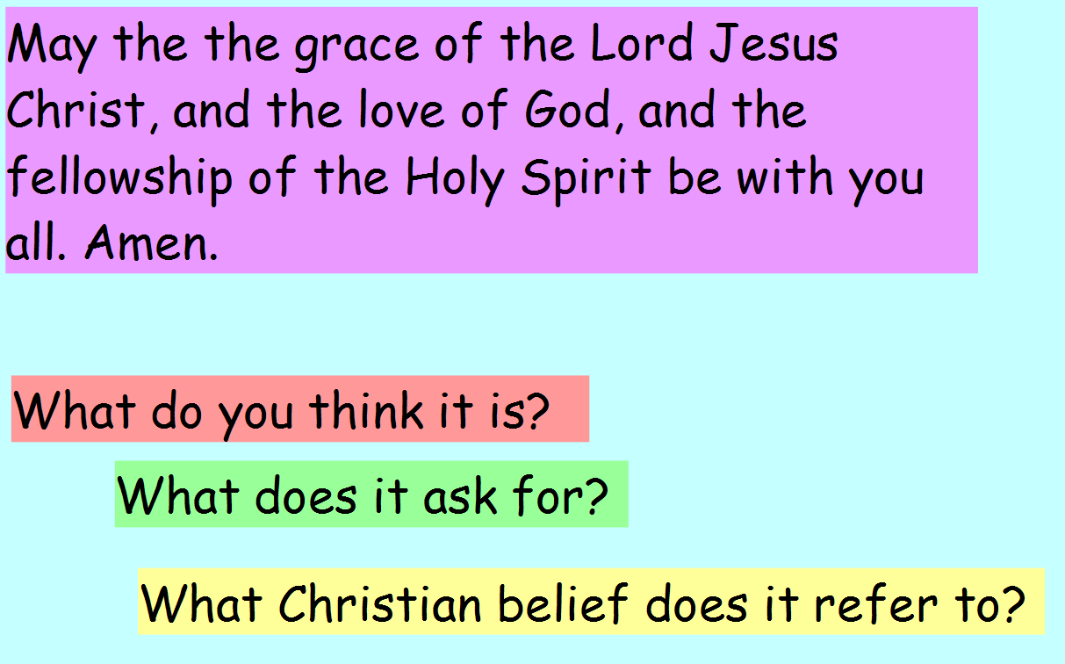

This was a blessing given by St Paul at the end of one of his letters to the Corinthians. It is a different type of prayer not addressed to God but blessing to the people. It is often called “The Grace” and used by many Christians especially in church. You may have heard this ‘let’s say Grace’ before lunch.

Task
- Create your own image of the Trinity and label it with God the Father, God the Holy Spirit and God the Son.
- Match the words taken from the Bible to the correct aspect of the Trinity.

God the Father | God the Son | God the Holy Spirit
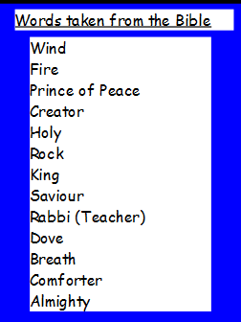

Challenge
Why do you think the Trinity is so important to Christians?

