Rabbits Home Learning
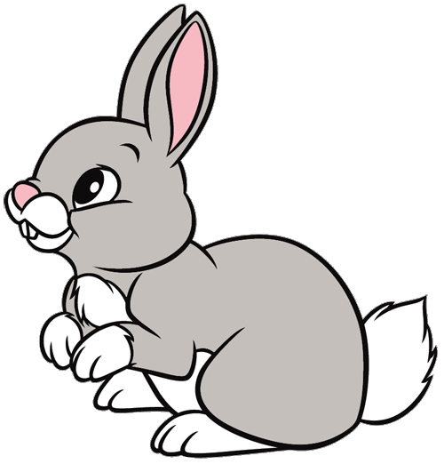
Monday 1st February
English
This week it’s all about dogs!
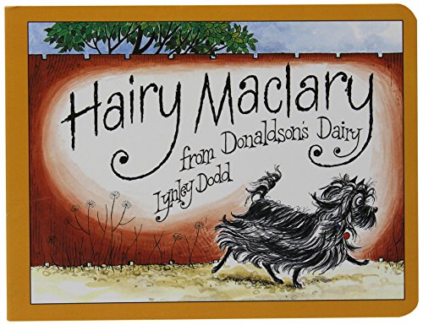
Can you remember all the names of the dogs from the story?
Which one is your favourite?
Tell someone why.
Draw or paint your own picture of your favourite dog,from the story or in real life. You could even make a model. If you can, write it’s name or ask a grown up to help you.

https://www.youtube.com/watch?v=lb0c-YnhCdQ
Read aloud version.

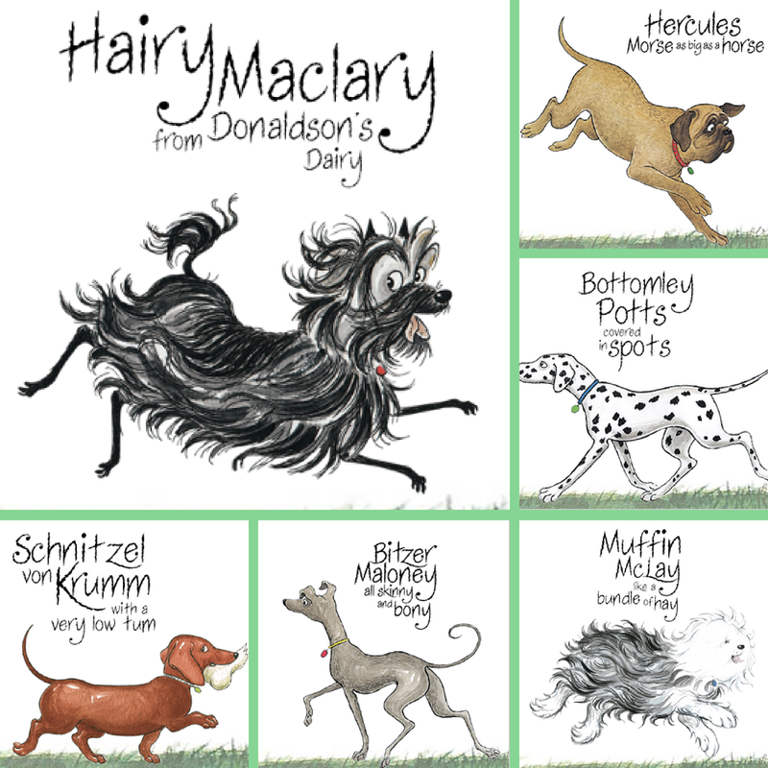
RWI
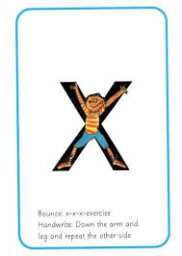
Can you write these words with an ‘x’?
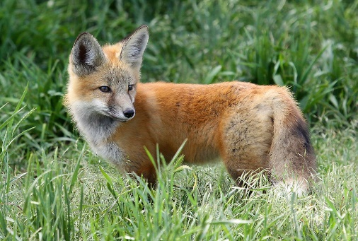

Maths
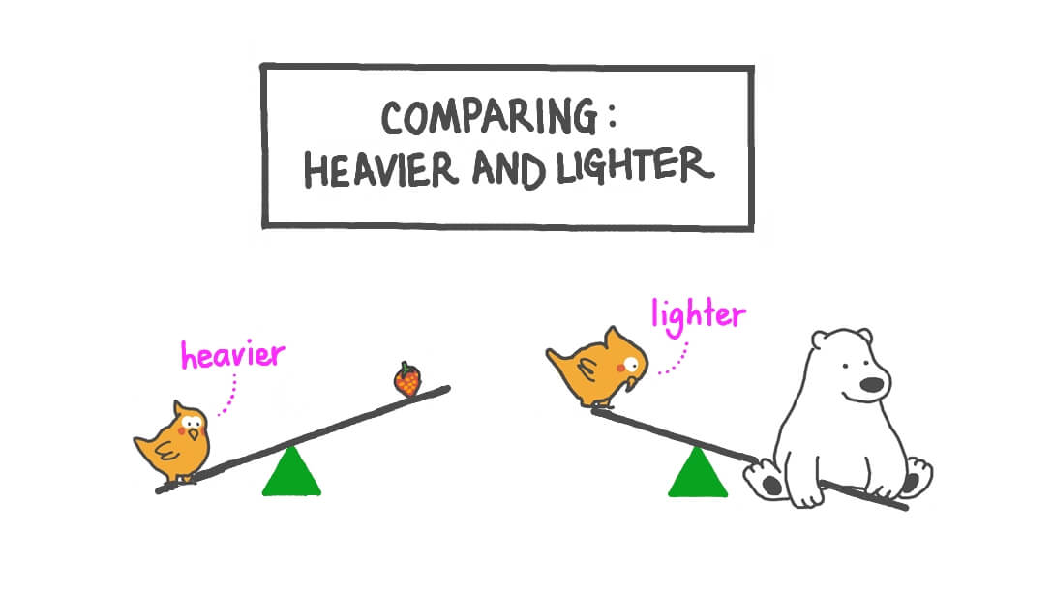
Have a look at the activity attached for today. What objects can you compare?

The Numberjacks are exploring ‘getting heavy’.
https://www.youtube.com/watch?v=RrLIai7Wtls

