Rabbits Home Learning
Monday 11th January

This work for today is to go alongside our online meeting this morning. Some of it I will have explained but this is for everyone to access in case you weren’t able to make the ‘teams’ meeting.

https://www.youtube.com/watch?v=ehoGdGokXfc
Here’s a read aloud version if you want to hear the story again or you couldn’t join us today on Teams.
RWI
Please practice forming this letter correctly.

Down up, down up.
Fred needs help! Fred talk and then say the word!
wet win wag

Maths
Please complete the attached worksheet.
https://www.youtube.com/watch?v=_jxzZMw89qY&t=2s
Here’s a song to help practice counting to 10.
If possible could you print and make a number fan. Please email me if you don’t have access to a printer and I will get one to you.
We will be using these later in the week. Using card is better but paper will also work too.
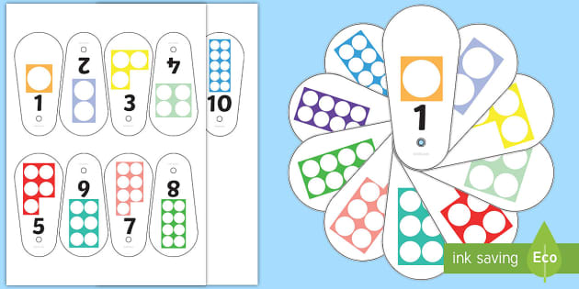
Thank you for the amazing photos you have sent so far.
Please send me photos and updates to my email. Keep in touch.
rgolden@charing.kent.sch.uk

