Rabbits Home Learning
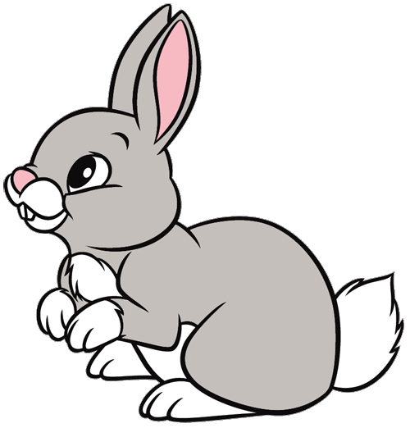
Tuesday 12th January

This work for today is to go alongside our online meeting this morning. Some of it I will have explained but this is for everyone to access in case you weren’t able to make the ‘teams’ meeting.
https://www.youtube.com/watch?v=ehoGdGokXfc
Here’s a read aloud version if you want to hear the story again or you couldn’t join us today on Teams.
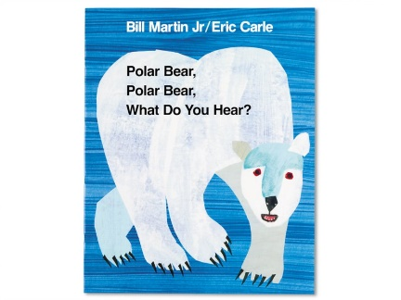

RWI
Please practice forming the letters in this sound correctly.
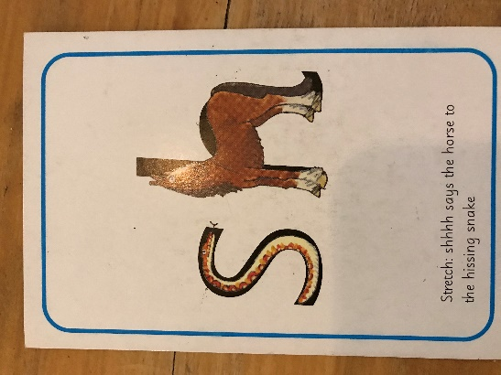
This sound we call ‘special friends’. When two or more letters make one sound together!
How many ‘sh’ words can you think of?
Draw a picture of 3 words you thought of. Have a go at writing the word too!

Fred needs help! Fred talk and then say the word!
shop shed fish 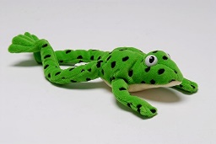

Make a polar bear mask…
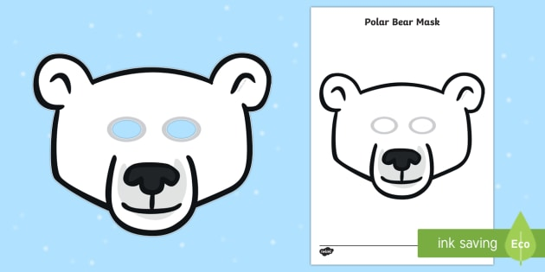
Make your own mask or print off the one attached.
Pretend to be the polar bear in the story…. How many animals can you remember and what noise were they making?
Try saying “I can hear a ………, ……….. in my ear!”
Maths
Join in with the number song.
https://www.youtube.com/watch?v=D0Ajq682yrA
Thank you for the amazing photos you have sent so far.
Please send me photos and updates to my email. Keep in touch.
rgolden@charing.kent.sch.uk

