Rabbits Home Learning
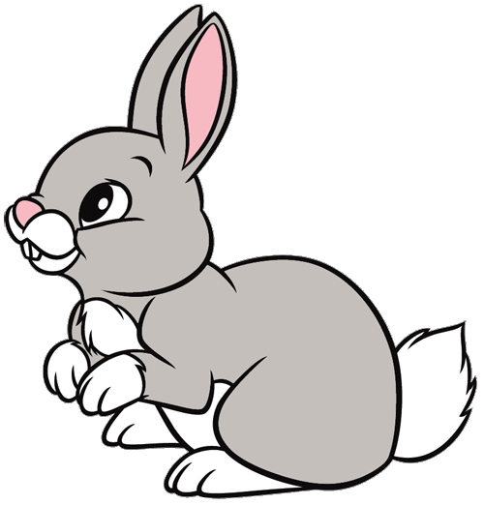
Wednesday 13th January

This work for today is to go alongside our online meeting this morning. Some of it I will have explained but this is for everyone to access in case you weren’t able to make the ‘teams’ meeting.
https://www.youtube.com/watch?v=ehoGdGokXfc
Here’s a read aloud version if you want to hear the story again or you couldn’t join us today on Teams.
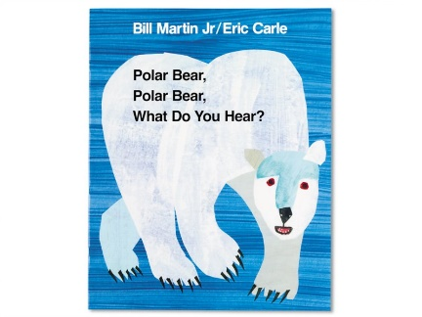

RWI
Please practice forming the letters in this sound correctly.

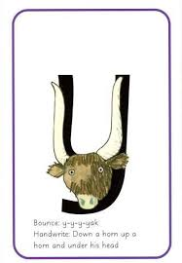
This is a yak!
Remember to say ‘down a horn, up a horn and under his head’ when you write the letter.
Fred needs help! Fred talk and then say the word!
yes yum yet yak 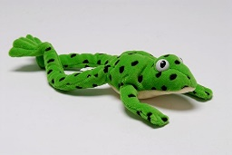

Polar Bears

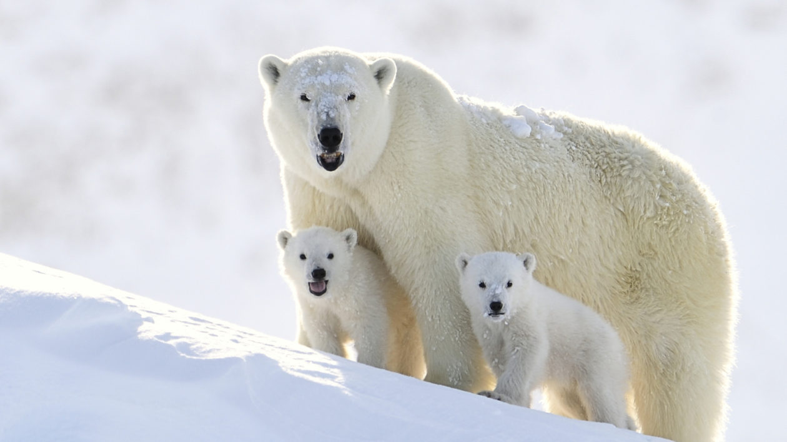
Can you find out about polar bears?
Where do they live? What do they eat?
Are they pets or wild animals?

Maths
Join in with the number song.
https://www.youtube.com/watch?v=D0Ajq682yrA

Make yourself number cards from 1-10 (or ask an adult to make them for you. Can you add the correct number of animals to the number card?
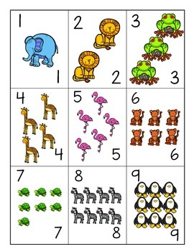My 10 is missing!!
You could make yours with all dinosaurs on them or cats and dogs, anything you like.
Now cut them up and ask someone to hide them around the room. How quickly can you find all 10 cards? Count them to make sure you have all 10!

Please can you keep your cards in case we need to use them again. Thanks.

Thank you for the amazing photos you have sent so far.
Please send me photos and updates to my email. Keep in touch.
rgolden@charing.kent.sch.uk

