Rabbits Home Learning
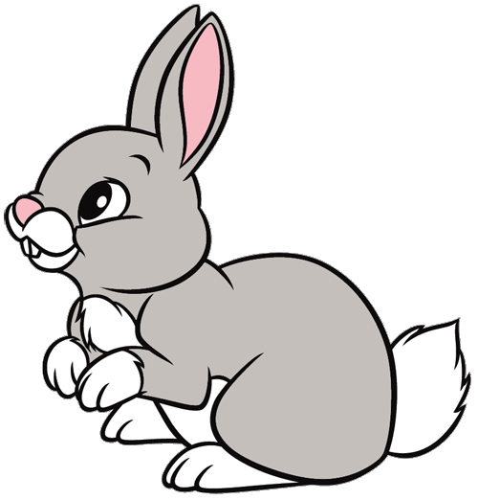
Thursday 14th January

This work for today is to go alongside our online meeting this morning. Some of it I will have explained but this is for everyone to access in case you weren’t able to make the ‘teams’ meeting.
https://www.youtube.com/watch?v=ehoGdGokXfc
Here’s a read aloud version if you want to hear the story again or you couldn’t join us today on Teams.
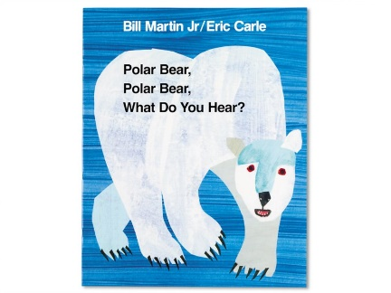

RWI
Today we reviewed lots of sounds you have already learnt and practiced fred talking and reading some words.

Please have a look at the words on the attached sheet and match them to the pictures.

Polar Bears
https://www.youtube.com/watch?v=--xEE7K67Xo
This is a short video about polar bears.
And then another about some adorable polar bear cubs.
https://www.youtube.com/watch?v=N8JD_P2J24g

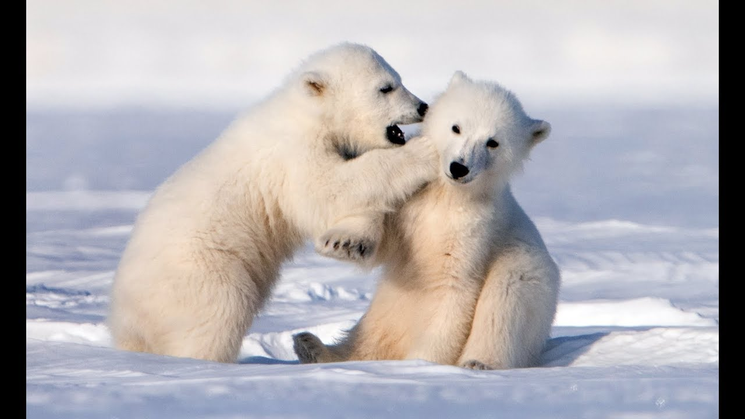

Maths

https://www.youtube.com/watch?v=i5Q2qbg4RXg
Enjoy watching this episode of the Numberjacks.

Then try this number quiz with the Numberblocks
https://www.bbc.co.uk/cbeebies/puzzles/numberblocks-easy-patterns-quiz?collection=numbers-and-letters

Thank you for the amazing photos you have sent so far.
Please send me photos and updates to my email. Keep in touch.
rgolden@charing.kent.sch.uk

