Rabbits Home Learning
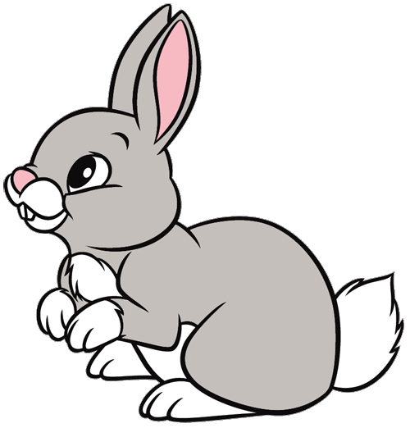
Friday 15th January
Physical development/ English
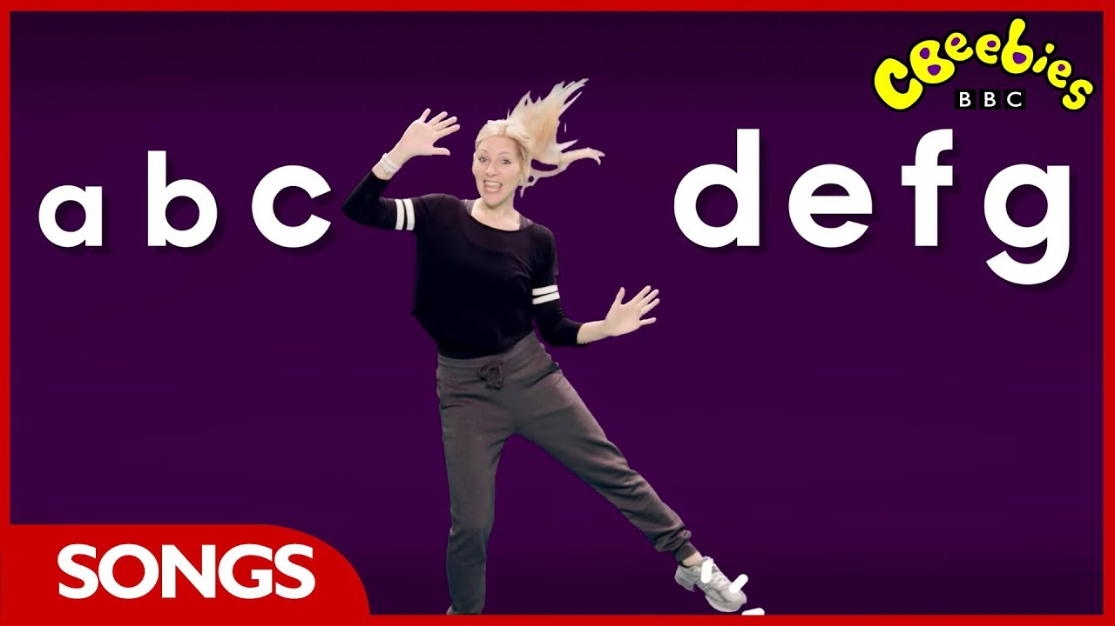
Join in with this fun song about the alphabet. Make sure you get up and copy the moves!

https://www.bbc.co.uk/teach/supermovers/ks1-english-alphabet-with-naomi-wilkinson/zjjy2sg
This week we have found out all about polar bears.
Today and over the weekend, make a picture or a model of a polar bear. Here are some ideas but you could even make polar bear biscuits!
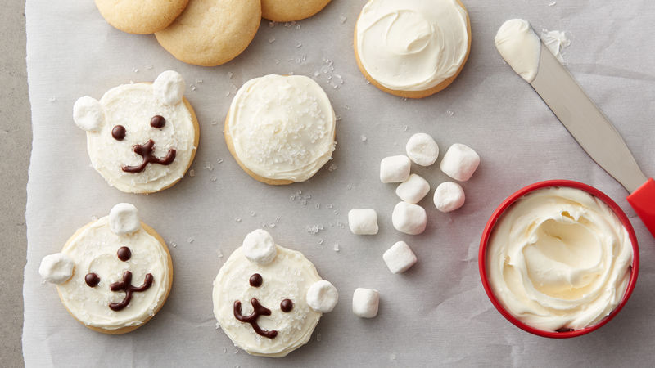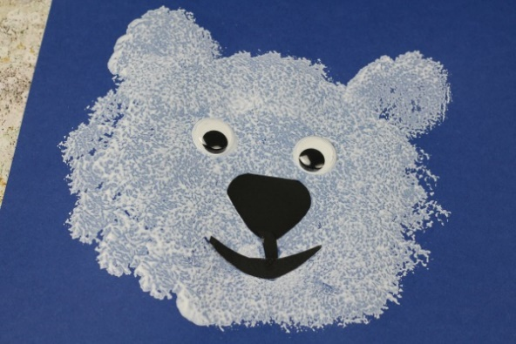
Bring your model or pictures to show me on Monday….. if you’ve eaten them, don’t worry!
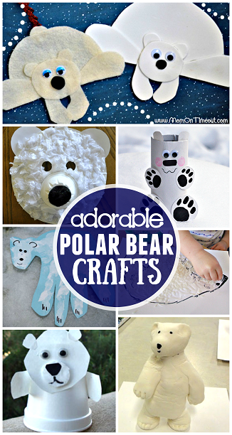
There’s an attachment of a paper model to make if you want it.
I know you all love Andy and his adventures, here’s one with polar bears!
https://www.bbc.co.uk/iplayer/episode/b01kvmbk/andys-wild-adventures-series-2-10-polar-bears
What other bears are there?
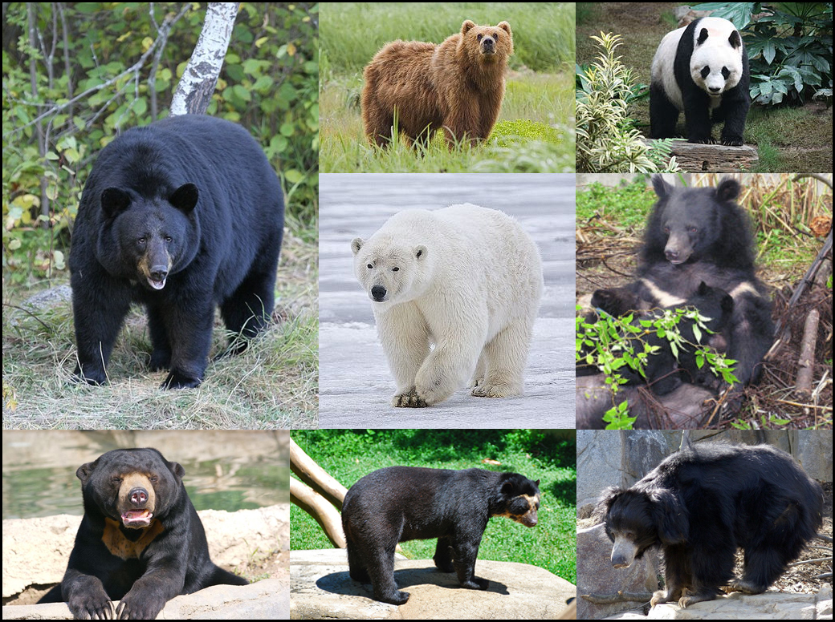
Have you got a toy bear at home?

Thank you for the amazing photos you have sent so far.
Please send me photos and updates to my email. Keep in touch.
rgolden@charing.kent.sch.uk

