Rabbits Home Learning
Monday 18th January
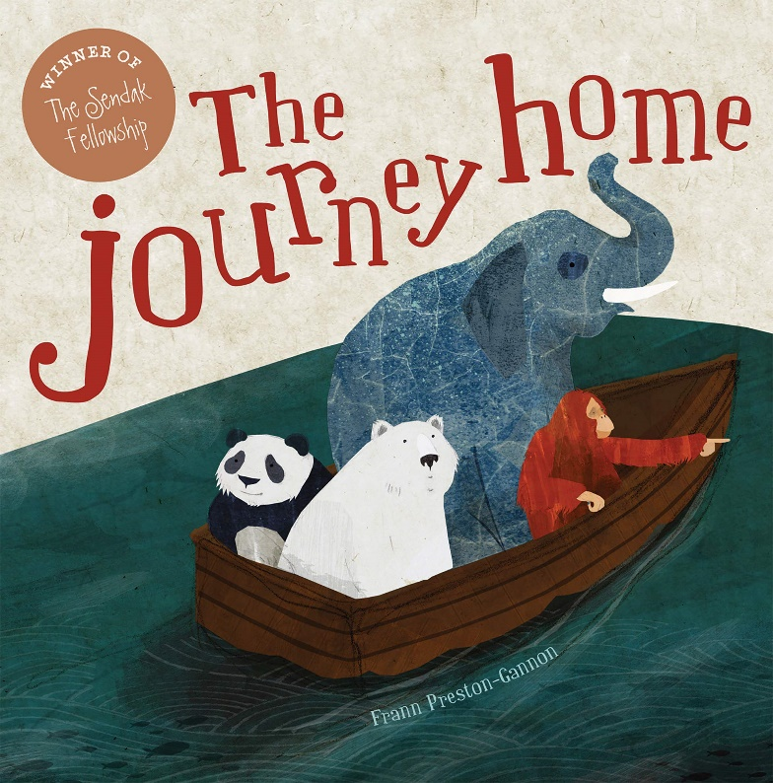
https://www.youtube.com/watch?v=_avcOTOECAw
A read aloud version of the story.

Can you tell someone at home…? What does ‘endangered’ mean? Why are the animals having to leave their homes?
https://www.youtube.com/watch?v=VrokfZ6mD5A&feature=youtu.be
Watch this video to find out about the most endangered animals.
Can you make a poster about saving one of these animals?

Maths
How many 2D shapes can you think of?
Have a look around your house. Are there any objects which are 2D shapes?
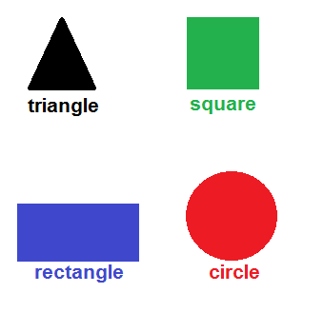
These are the basic shapes. Do you know all of these?
Look at the picture on the next page.
How many circles are there?

How many rectangles are there?

How many triangles are there?

How many squares are there?
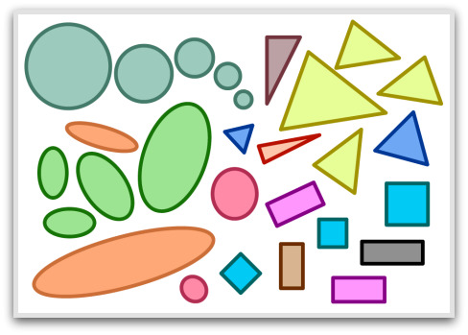
If you have time, draw some shapes or make a picture out of 2D shapes.
Thank you for the amazing photos you have sent so far.
Please send me photos and updates to my email. Keep in touch.
rgolden@charing.kent.sch.uk

