Rabbits Home Learning
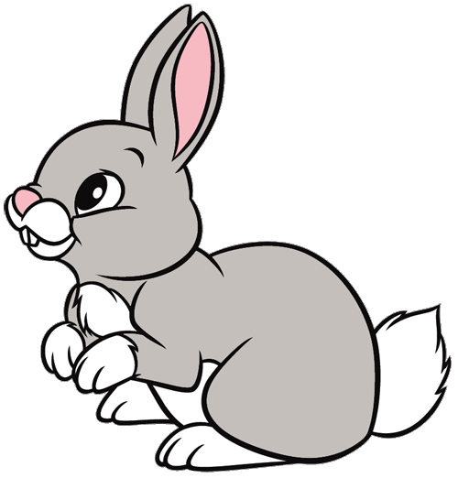
Tuesday 19th January
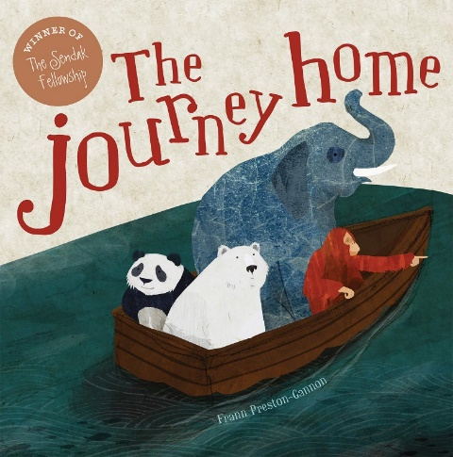
https://www.youtube.com/watch?v=_avcOTOECAw
A read aloud version of the story.

Maths
Have a look at these objects, what shape are they?
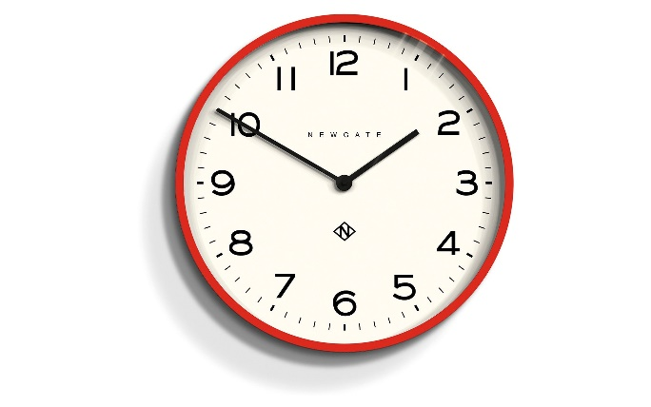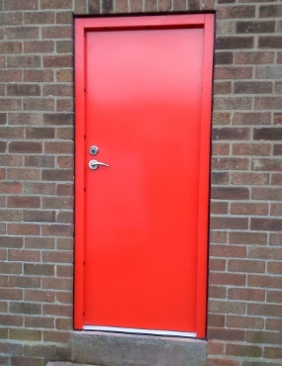

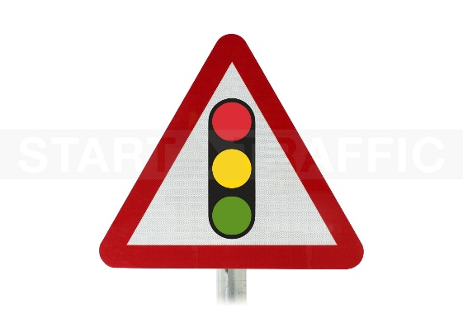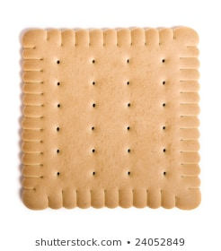
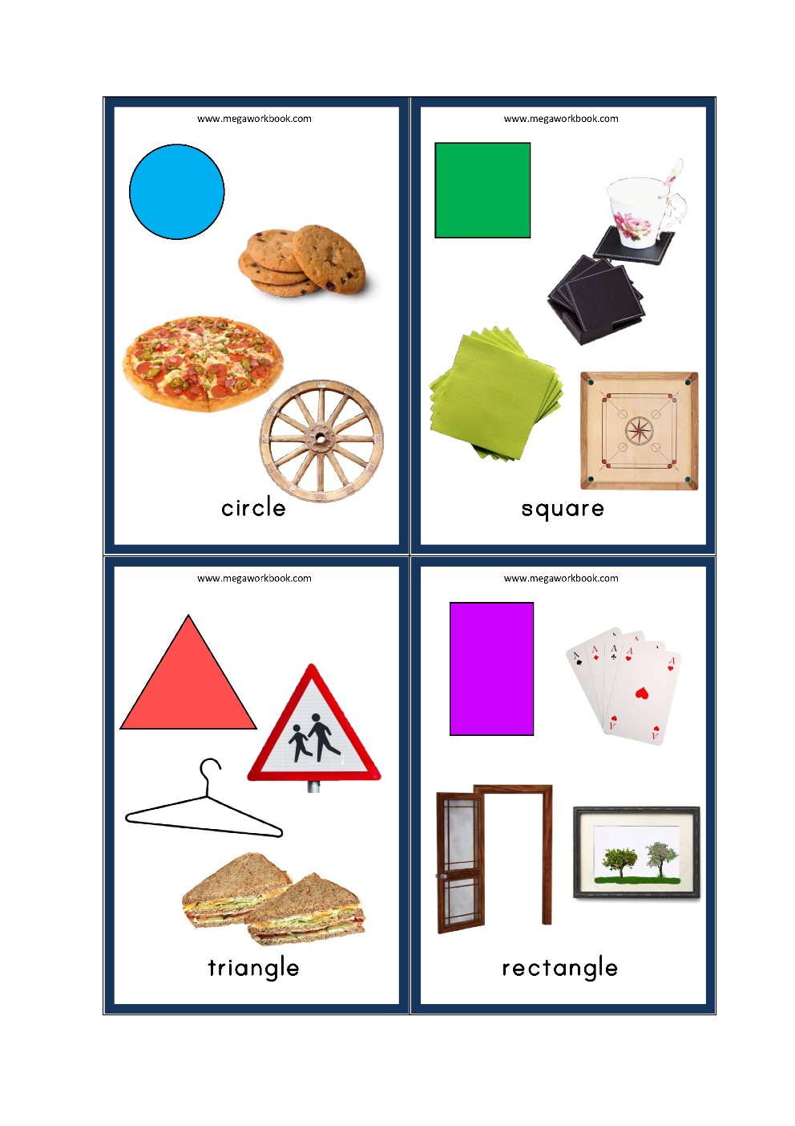
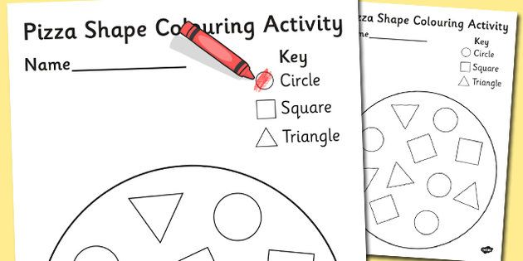

Please use the attached sheet to choose colours for your very own 2D pizza!

RWI
Please use the attached workbook to practice the ‘th’ sound we learned yesterday.
If you don’t have access to a printer, please practice writing the ‘th’ sound and draw a picture of something with a ‘th’ in it.
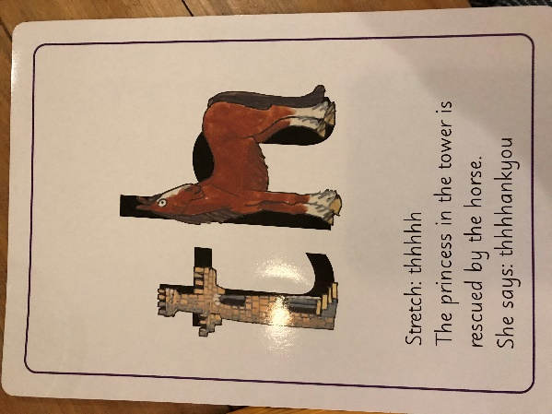
Thank you for the amazing photos you have sent so far.
Please send me photos and updates to my email. Keep in touch.
rgolden@charing.kent.sch.uk

