Rabbits Home Learning
Wednesday 20th January

Maths
Please use the cut and stick sheet attached.
Can you remember the new shape name we learned today? It has 5 sides!
RWI
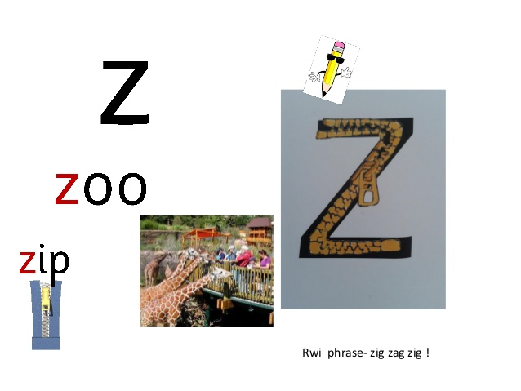
Have you ever been to a zoo?
Maye you’ve been to a wild life park instead? Can you remember any of the animals you saw there?
https://www.youtube.com/watch?v=Dd0uIfhz0A8
This is a live camera from Port Lympne animal park. Have a look and see if you can see any animals!

Today I’d like you to make a den at home.
Use blankets and cushions and whatever else you can find.
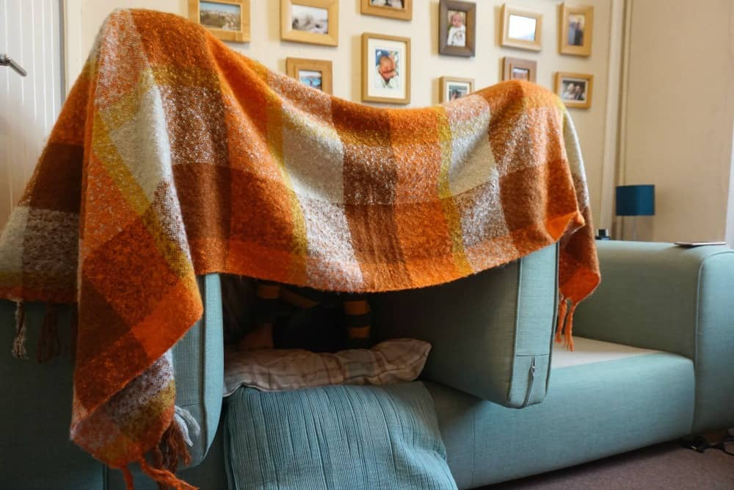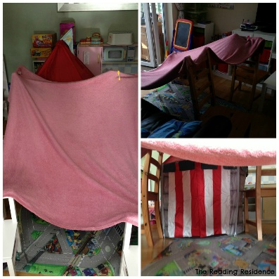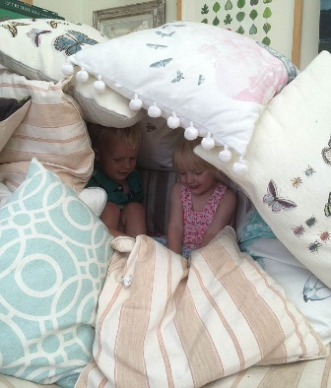
How dark is it? Can you still see inside it or do you need a torch?
Which animals do you think might like to live in a den or somewhere dark?

Animal Episodes!
Thank you for the amazing photos you have sent so far.
Please send me photos and updates to my email. Keep in touch.
rgolden@charing.kent.sch.uk

https://www.bbc.co.uk/iplayer/episodes/b083gr3k/andys-baby-animals
https://www.youtube.com/watch?v=S5XDW09sECs
Let’s Play (Animal Ranger)

