Rabbits Home Learning
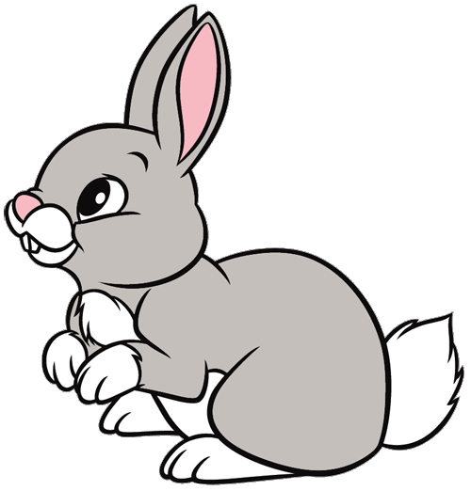
Thursday 21st January

English
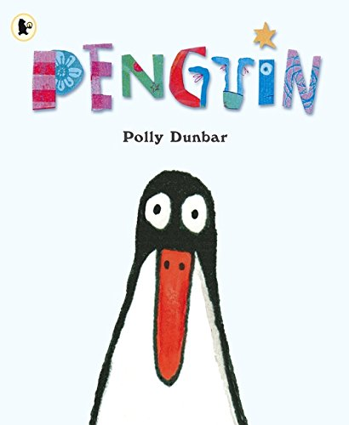
This is the story we are reading today.
https://www.youtube.com/watch?v=UCYMMUYRQdc

If you could have a pet….. any animal at all…… what would it be?
Draw and colour a picture of your pet and write what it is. Give it a name! If you have paints, paint a picture instead.

Maths
These are our two new shapes.
pentagon hexagon octagon
Can you cut out and sort the objects into the correct shape using the worksheets attached.
Please let me know if you would like this printed to collect today from school.

Can you play the number bingo we played today? If you haven’t got a dice use your number cards and turn them over to see which number you can cross out.

Knowledge and Understanding of the World
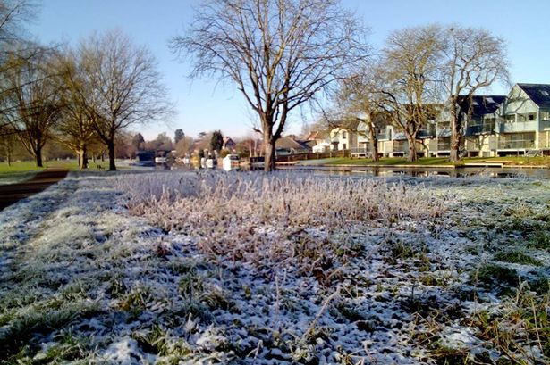
Do you know what time of year it is?
What season is it? Spring, Summer, Autumn or Winter?

Before it starts raining again today……… go outside in your garden, at school or for a walk. What can you see? Are there signs of Winter?
Use the checklist attached to go on a Winter hunt!

