Rabbits Home Learning
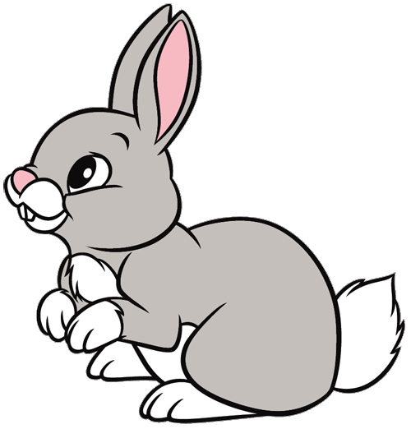
Friday 22nd January
So far this term we have been finding out about wild animals.
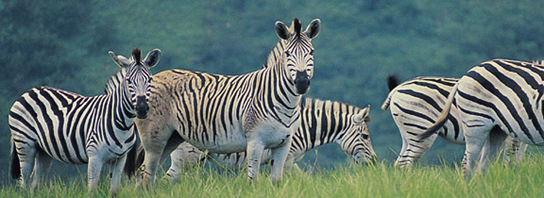
Choose your favourite wild animal (one that is alive!). What amazing facts can you find out? Is it an endangered species?
I’d like you to make a short video presenting your ideas. You can tell me facts about the animal or make a mask and pretend to be the animal. How does it move? What does it sound like? If you have some toy animals, set them up and film them or make a model and explain how you made it. Any other ideas are very welcome.
Remember it only has to be very short and definitely doesn’t have to be perfect. Children love to watch themselves on film too so just have fun!

For the next 3 weeks we are learning about different pets. Can you let me know which pets you have at home and I’ll try my best to include them.

Email to rgolden@charing.kent.sch.uk

