Rabbits Home Learning
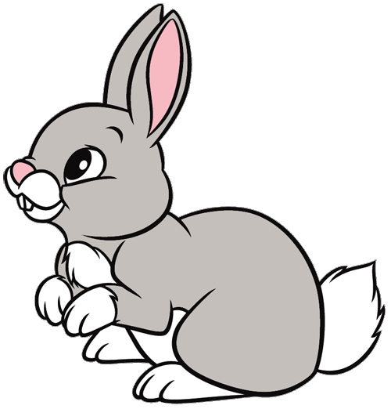
Monday 25th January

English
Our stories this week are all about rabbits.
Do you know someone who has a pet rabbit?
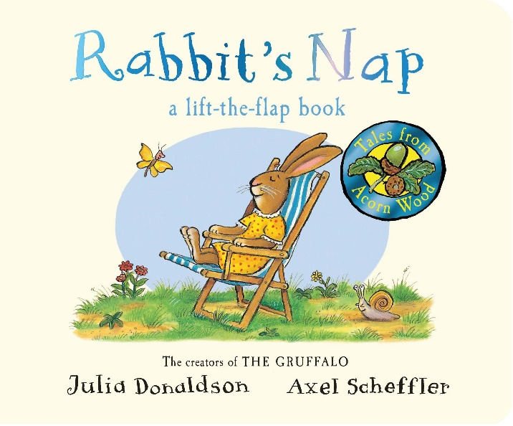
https://www.youtube.com/watch?v=w8hopmHMSsg

RWI
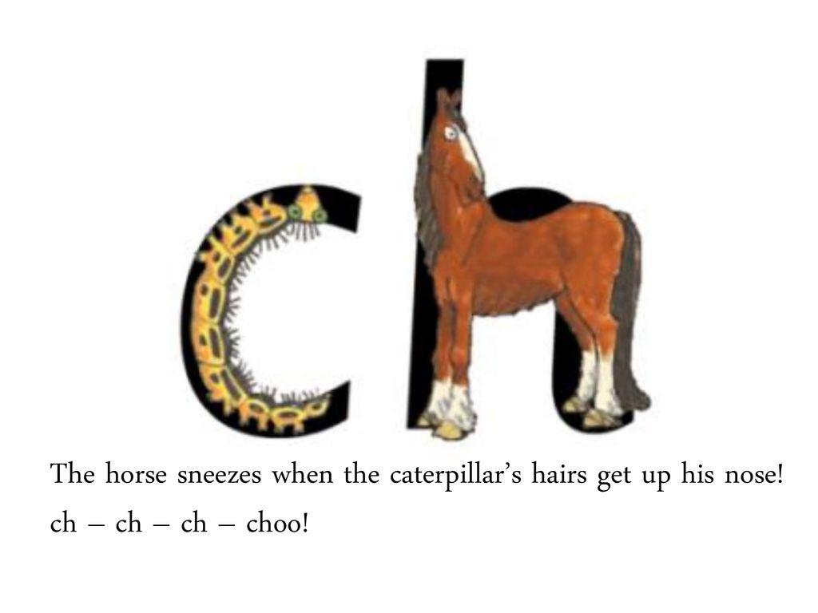
Draw a picture of 3 things you can eat which start with a ‘ch’ sound!
How many words can you think of which state with a ‘ch’ sound? Draw and write.
Maths

Can you tell what we are learning about this week?
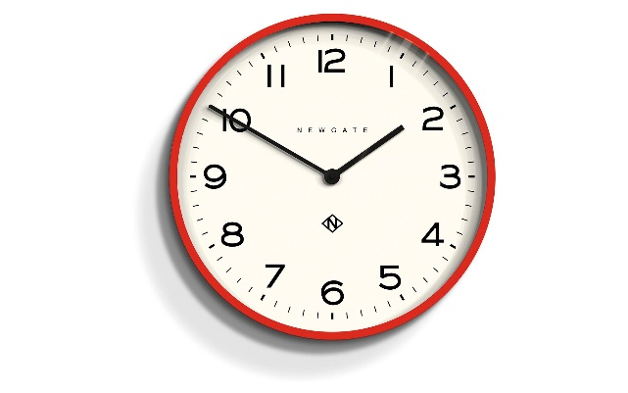
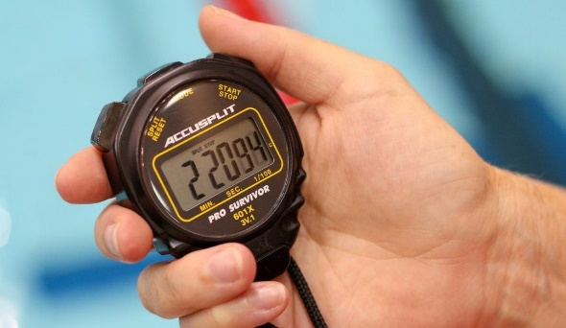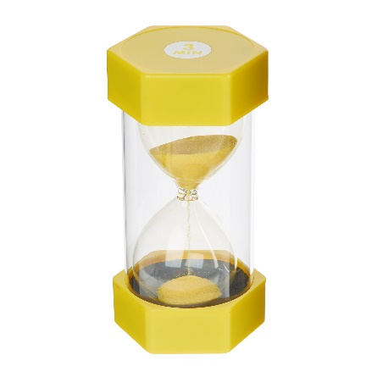

Please keep a record of things you do in the morning and the afternoon.
You can do this with photos or pictures.
You can also print and use the attachment if you want.?

How many things can you find in your house which tell the time?

Ask someone in your family to time you.
How many jumps can you do in 1 minute?

