Rabbits Home Learning
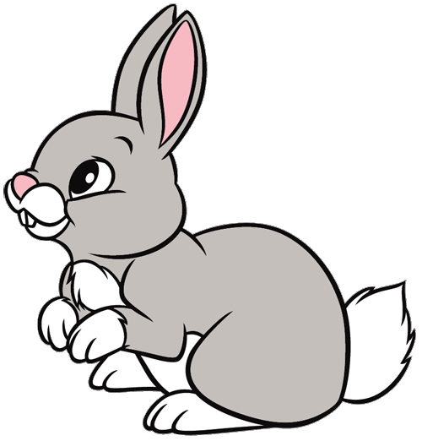
Tuesday 26th January
English
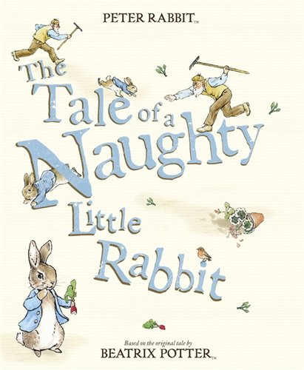
Can you remember the names of the rabbits in the story?
How many sisters does Peter have?
What does Peter like to eat?
What does he leave behind in Mr McGregor’s garden?
https://www.youtube.com/watch?v=F2qg1JYj1TE

Watch an episode of Peter Rabbit on cbeebies or youtube.
https://www.bbc.co.uk/iplayer/episodes/b052sx2p/peter-rabbit
RWI
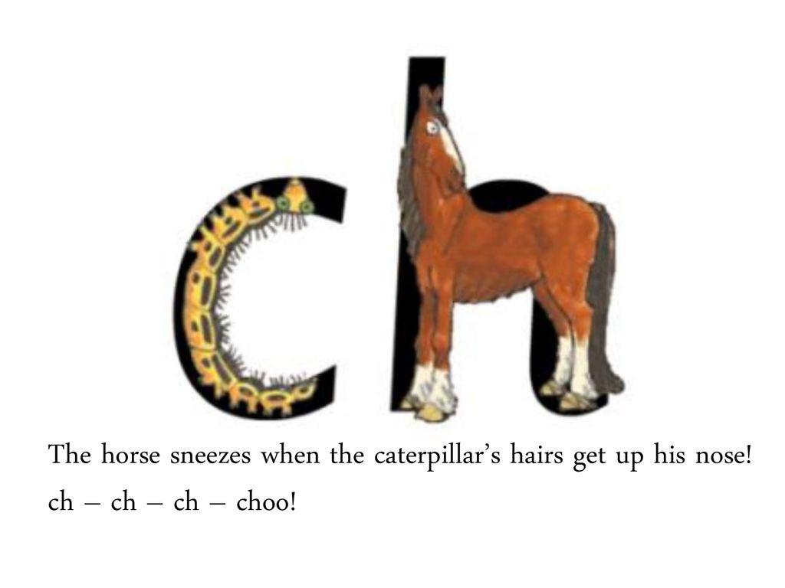
Match up the pictures with the words on the attached sheet.

Maths
Make your own clock today using the print out or use a paper plate and stick on your own numbers.
Practise saying all the numbers around the clock, starting with 1.
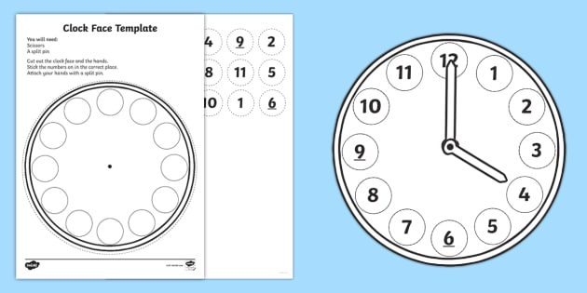
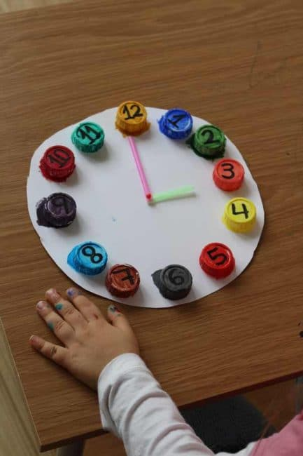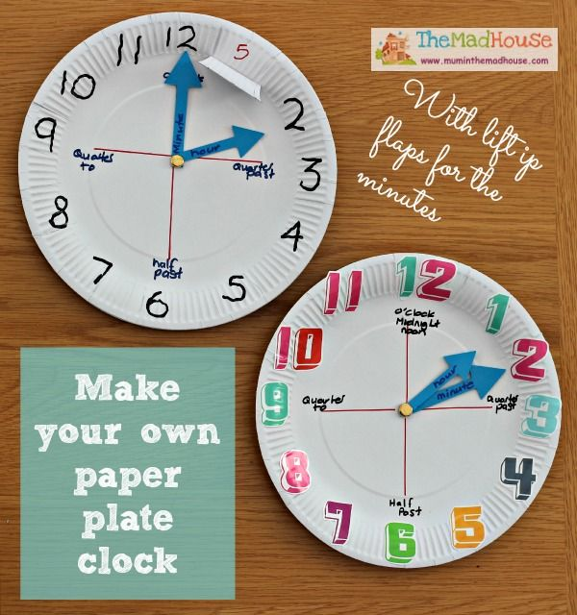
Outside learning
Peter Rabbit loves eating things in the garden. Go outside (before it rains this afternoon) and see what is growing. Is there anything that Peter could eat?
Can you draw a picture of Peter in Mr McGregor’s garden? What is he eating?
