Rabbits Home Learning
Wednesday 27th January
English
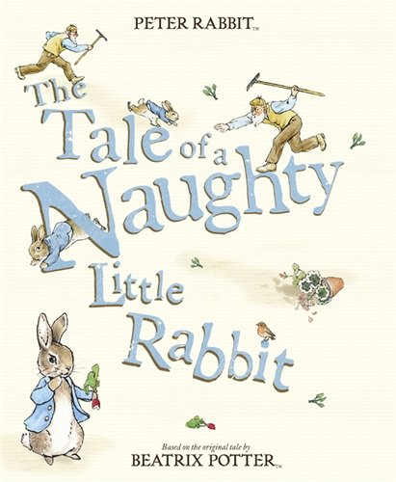
Listen to the story again.
https://www.youtube.com/watch?v=F2qg1JYj1TE

Watch an episode of Peter Rabbit on cbeebies or youtube.
https://www.bbc.co.uk/iplayer/episodes/b052sx2p/peter-rabbit
RWI
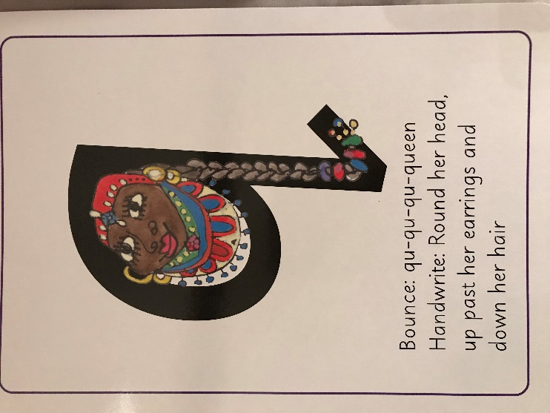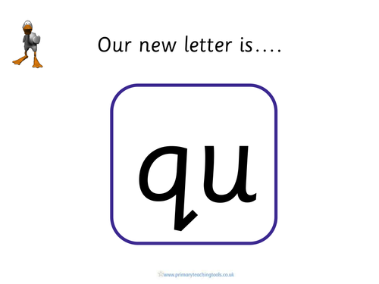

Today’s new ‘special friends’.
Maths
Sequence the pictures from the story of Peter Rabbit. Use the pictures attached and the time sheet.
What happens in the morning, the afternoon and the evening?

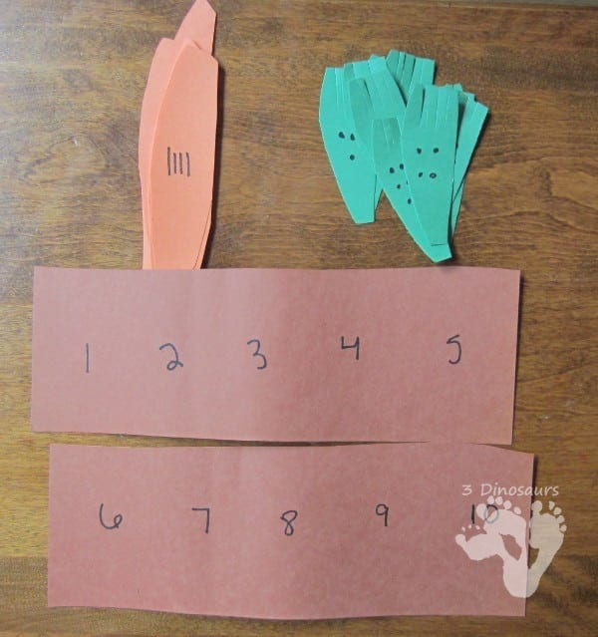
A fun and simple number-matching activity you can make with brown, orange, and green construction paper and a pen or felt tip. Prepare the “dirt” by writing numbers 1–10 on the brown paper. Cut out orange carrots and mark them with corresponding tally marks. Prepare green carrot tops with corresponding dots. Put your carrots and carrot tops together and then tuck each carrot into the proper place in the garden.

There is also a 2D shape Bunny to make and a Peter rabbit counting sheet.
Please don’t feel you have to do all of the activities but they are there is you want to.

