Rabbits Home Learning
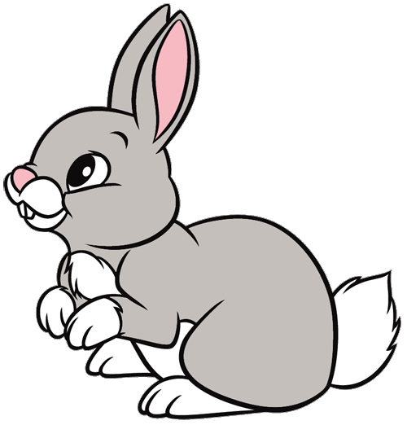
Thursday 28th January
English
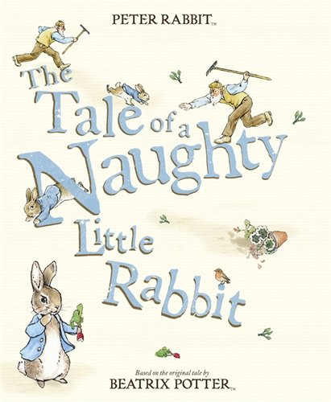
This is our story this week
https://www.youtube.com/watch?v=F2qg1JYj1TE

There are some character stick puppets to make today. Cut them out and stick them onto a lolly stick or anything you have at home.
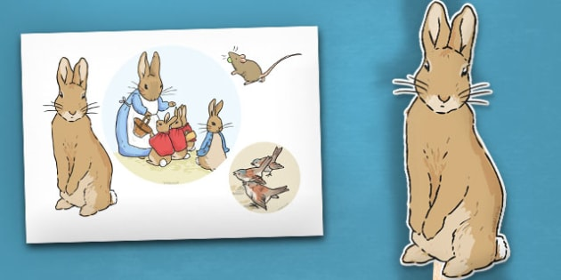
Can you retell the story? Show someone at home your story.
Don’t forget to give the characters different voices, especially Mr McGregor!

What can you find out about rabbits today?
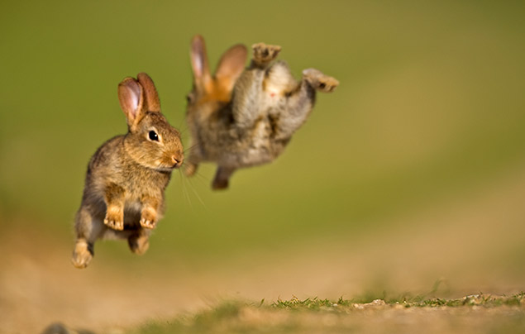
RWI
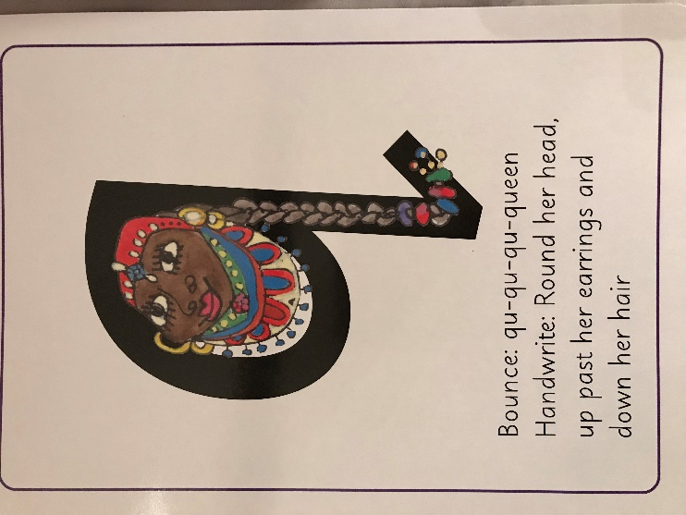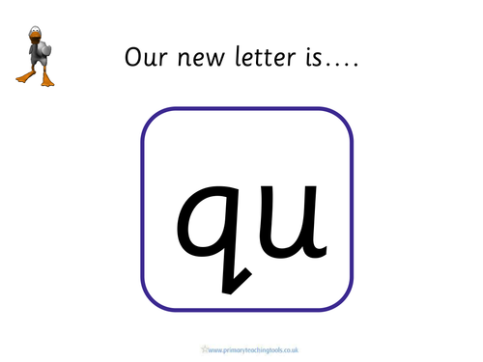
Practise writing…
quit
(Parents….Can you make sure you get your child to put the little flick on the ‘q’, I can’t find a font that does!)

Maths
Sing this song at home today. Use the clock you made to show the time.

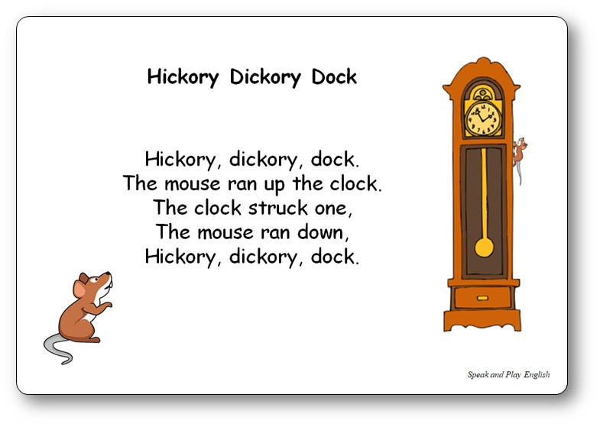

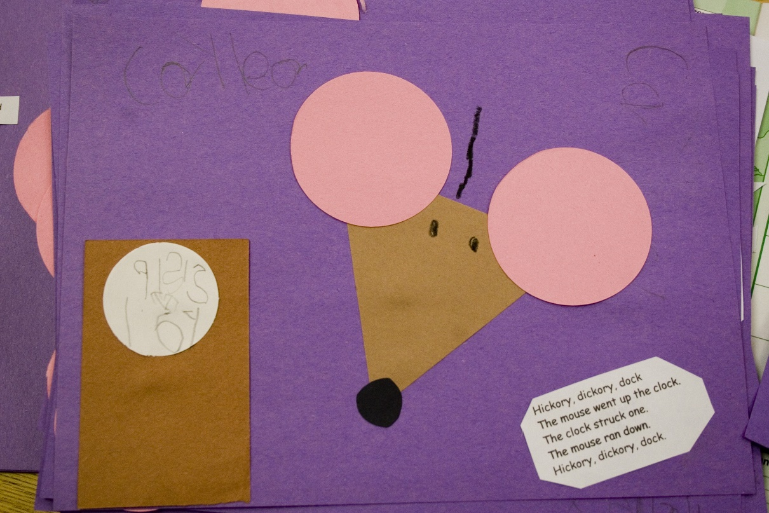
Can you make your own picture to show the clock and the mouse?
What time is it?

If you didn’t finish all the activities from yesterday, have a look at see what you still have left to do.

Watch an episode of Peter Rabbit on cbeebies or youtube.
https://www.bbc.co.uk/iplayer/episodes/b052sx2p/peter-rabbit

