Rabbits Home Learning
Friday 29th January

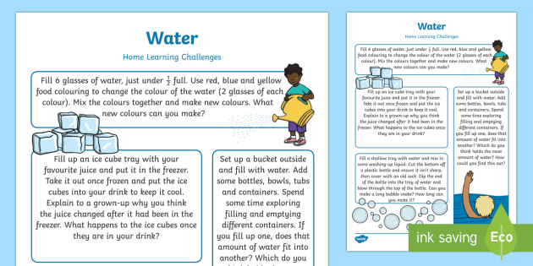
This pdf is attached to the home learning today.
Have fun exploring water today or over the weekend.

If your pet was sick, who could help you?

Watch ‘Let’s play’ all about vets. Get some of your toy animals and make your own vet surgery. How many sick animals can you help?
Use the appointment sheet to book your animals in for an appointment.
https://www.youtube.com/watch?v=m0QD0ioXA4c

RWI
For parents- This video explains how we teach the blending part of RWI. Don’t worry initially about using the letter cards. Just ‘play’ with sounds and practice blending.
https://www.youtube.com/watch?v=dEzfpod5w_Q

For the children- These catch up sessions are available on Youtube.
https://www.youtube.com/channel/UCo7fbLgY2oA_cFCIg9GdxtQ/featured
Start with the first video which practices ‘h’.
The other are videos are a bit harder and contain some special friends we haven’t learned yet.

